Real-time Nursery Smart Attendance System Using Facial Recognition

By
Tendai N. Munyawiri
N02017565Y
Supervisor
Mrs. M. Dzinomwa

A PROJECT REPORT SUBMITTED TO
The Department of Informatics at the National University of Science and Technology in partial fulfilment of the requirements for the degree of
BACHELOR OF SCIENCE (HONS) INFORMATICS
Faculty of Applied Sciences

[04 June 2024]

Preface
The research contained in this project was completed by the candidate based on the
Department of Informatics, at the National University of Science and Technology.
The contents of this work have not been submitted in any form to another university and,
Except where the work of others is acknowledged in the text, the results reported are due to
Investigations by the candidate.

Candidate Signature.........................................................................

Supervisor Signature...........................................................................

Date ......................................................

Declaration

I can confirm that this work was done under my supervision, and it is the candidate’s original work. As the candidate’s supervisor, I have approved this dissertation for submission.

Supervisor Signature............................................................

Abstract

The most crucial factor in the classroom is attendance, which has a direct bearing on how well children perform academically. Class engagement and learning increase with the efficiency of the attendance system. Manual attendance checking is difficult to carry out, especially when dealing with nursery age groups because they lack the maturity to understand the importance of attendance tracking. Therefore, manual attendance tracking can be time-consuming, error-prone, and difficult to manage, which can lead to frustration for teachers. This study focuses on the development of a nursery smart attendance system using facial recognition to streamline the process of monitoring student attendance, ensure process optimization, and come up with accurate reports that can be used for data-driven decisions. The InsightFace model is integrated into the overall system to facilitate the detection and recognition of faces in real-time. Comprehensive data visualisations and well-informed data reports are created for analysis. Overall, system and model maintenance procedures are implemented to ensure that the attendance information in the system is accurate and reliable.

Acknowledgements

I would like to express sincere gratitude to God for giving me the wisdom, strength, and ability to complete this project. My heartfelt thanks also go out to my family, whose unyielding support and financial assistance were instrumental in my journey. Their trust in my abilities has been a beacon of hope and a constant source of motivation. I would also like to thank my supervisor, Mrs. M. Dzinomwa, for her unwavering support and guidance. Her constructive criticism and feedback helped me stay motivated to produce quality work throughout the entire project. Lastly, I would like to thank my friends for their constant support during all the challenging experiences encountered during this project.
Table of Contents
Preface i
Declaration ii
Abstract iii
Acknowledgements iv
Chapter 1: Introduction 1
1.1 Introduction 1
1.2 Background 1
1.3 Problem Description 1
1.4 Aim 2
1.5 Objectives 2
1.6 Proposed Study 2
1.7 Target market 3
1.8 Competitive advantage 3
1.9 Funding Required 4
1.10 Sustainability 4
1.11 Project Timeline 4
1.12 Report Organization 4
1.13 Conclusion 6
Chapter 2: Literature Review 2
2.1 Introduction 2
2.2 Review Method 2
2.3 Research Question 3
2.4 Preliminary research and idea validation 3
2.5 Database search strategy 3
2.6 Inclusion and Exclusion Criteria 4
2.6.1 Inclusion criteria 4
2.6.2 Exclusion Criteria 4
2.6.3 Study selection 4
2.7 Data Extraction 6
2.8 Data Reporting and Results 6
2.8.1 Smart Attendance Techniques Data Reporting 6
2.8.2 Research Theories 12
2.8.3 Research Origins 12
2.9 Literature Analysis Discussion 12
2.9.1 Smart Attendance Overview 13
2.9.2 Face detection and face recognition Review 13
2.9.3 Other techniques in Smart attendance systems. 17
2.10 Research Gap 18
2.11 Proposed Solution 19
2.12 Conclusion 20
Chapter 3: Methodology 21
3.1 Introduction 21
3.2 Research Methodology 21
3.2.1 Mixed Methods Research: 21
3.2.2 Alternatives 21
3.2.3 Justification of Mixed Methods Research 22
3.3 Data Science Methodology 22
3.3.1 Cross-Industry Standard for Data Mining (CRISP-DM) 22
3.3.2 Dominance and Limitations of CRISP-DM to the study 25
3.3.3 Alternatives 25
3.3.4 Justification of using CRISP-DM methodology 26
3.4 Software Development Methodology 27
3.4.1 Scrum 27
3.4.2 Dominance of Scrum and its Limitations to the Study 29
3.4.3 Software Development Methodology Alternatives 29
3.4.4 Justification for Scrum as the chosen Software Development Methodology 30
3.5 Development Tools Required 31
3.6 Conclusion 31
Chapter 4: System Analysis and Design 32
4.1 Introduction 32
4.2 System analysis 32
4.3 Requirements Specification 32
4.3.1 Functional Requirements 32
4.3.2 Non-Functional Requirements 33
4.4 System Design 34
4.4.1 User Management (Client Application) 35
4.4.2 User Identity and Access Management 36
4.4.3 Real-time Face Recognition Inference and Attendance Reporting 37
4.4.4 Fast Face Recognition Model 38
4.4.5 Redis Database Design 39
4.5 Conclusion 40
Chapter 5: Implementation and Testing 41
5.1 Introduction 41
5.2 System Implementation 41
5.2.1 Model Configuration 41
5.2.2 Model Testing 42
5.2.3 Streamlit and Web Real-Time Communication Configuration 43
5.2.4 Real-time Detection and Facial Features Extraction 43
5.2.5 Redis Database Configuration and Saving Extracted Facial Features 44
5.2.6 Real time-Prediction and Machine Learning Search Algorithm 45
5.2.7 Reporting 48
5.2.8 System Authentication 49
5.3 User Interface 49
5.3.1 Home Page 50
5.3.2 Real-time Prediction 51
5.3.3 Admin View and Dashboard 52
5.3.4 Registration Page 53
5.3.5 Attendance Reports 54
5.3.6 User Management 58
5.3.7 Database 58
5.4 System Testing 59
5.4.1 Unit Testing 59
5.4.2 Integration Testing 59
5.4.3 User Acceptance Testing 59
5.5 Conclusion 59
Chapter 6: Conclusion 60
6.1 Introduction 60
6.2 Review of Project Objectives 60
6.3 Challenges and Limitations 60
6.4 Future Work and Recommendations 61
6.5 Conclusion 61
References 62
Appendices 65
Appendix A: Parent Consent Form 65

List of Figures

Figure 2.1 SLR STEPS 2
Figure 2.2 Study Selection Strategy Flowchart 5
Figure 2.3 Kortli et al. (2020) Face Recognition Methods Classification 14
Figure 2.4 Shepley (2019) Deep Learning Face Detection 16
Figure 2.5 Proposed Experiment Setup 20
Figure 3.1 Hotz (2023) CRISP-DM Steps 23
Figure 3.2 Lee and Chen (2023) Scrum Methodology 27
Figure 4.1 System Architecture 34
Figure 4.2 Use Case Diagram 36
Figure 4.3 User Authentication Sequence Diagram 37
Figure 4.4 Real-time Face Recognition Inference Sequence Diagram 38
Figure 4.5 Fast Face Recognition Model Process Management Diagram 39
Figure 4.6 Redis Database Structure 39
Figure 5.1 Model Configuration 41
Figure 5.2 Images loading to the model 42
Figure 5.3 Facial Features Results Data Frame Snippet 42
Figure 5.4 WebRTC Configuration 43
Figure 5.5 Computer Vision Image Processing 43
Figure 5.6 Real-Time Detection 43
Figure 5.7 Real-time Detection Output 44
Figure 5.8 Database Connection 44
Figure 5.9 Saving data to Redis database code snippet 45
Figure 5.10 Saving data to Redis database code snippet 45
Figure 5.11 Cosine Similar and Equlidean Comparison Code snippet 46
Figure 5.12 Data frame showing Results from the algorithms 46
Figure 5.13 Cosine Similarity Algorithm 47
Figure 5.14 Real-Time Prediction Code Snippet 47
Figure 5.15 Real-time Prediction 48
Figure 5.16 Reporting Code Snippet 48
Figure 5.17 Admin System Authentication 49
Figure 5.18 Home Page 50
Figure 5.19 General Reports for Guardian 50
Figure 5.20 General Report View for Teachers 51
Figure 5.21 Real-Time Attendance Interface 51
Figure 5.22 Admin Login Page 52
Figure 5.23 Admin View Interface and Dashboard 53
Figure 5.24 Registration Interface 53
Figure 5.25 Nursery Attendance Reports Interface 54
Figure 5.26 Period over Period Nursery Attendance Report 54
Figure 5.27 Reports for a certain Date 55
Figure 5.28 Students Reports Interface 55
Figure 5.29 Current Day Reports for Students 56
Figure 5.30 Daily Attendance Statistics 56
Figure 5.31 Particular Student`s Attendance Report 57
Figure 5.32 Teachers Attendance Reports 57
Figure 5.33 User Management Interface 58
Figure 5.34 Redis Database Interface 58

List of Tables
Table 1.1 Project Timeline 4
Table 2.1 Database Hits 3
Table 2.2 Data Reporting 12
Table 2.3 Theoretical Frameworks Review 12
Table 2.4 Shepley (2019) Model Comparison 17

Introduction

Introduction
Even in this day and age of automation and technology, classroom management techniques remain mostly unchanged. The most crucial factor in the classroom is attendance, which directly affects how well children perform academically. Class engagement and learning increase with the efficiency of the attendance system. The researcher developed the concept of using modern technologies to automate this procedure to have a clean and orderly classroom. A facial recognition system, in conjunction with an appropriate computer system, will aid in achieving the research objectives. To achieve better performance, the researcher proposes to collect high-quality data, ensuring that the face images used for training and testing are of high resolution and quality. A friendly user interface must be implemented for the enrolment and registration of students in the database to be recognised. In addition, privacy and security techniques should be implemented to protect sensitive data.

Background
Student attendance throughout classroom hours is crucial, as it impacts students' overall academic performance. Conventional methods for recording student attendance in the classroom, such as roll call and sign-in, are inefficient and increase teachers’ workloads, resulting in a waste of instruction time (Puckdeevongs et al., 2020). These conventional methods can be replaced by facial recognition-based smart attendance systems. A facial recognition system is a technological innovation that can match a database of faces with a digital image or video frame that has a human face in it. Kortli et al. (2020) suggest that face recognition methods are classified into three categories: local, holistic, and hybrid approaches. These approaches for facial recognition can be classified based on their detection and recognition methods. The first method focuses only on specific facial features and does not take the entire face into account. In contrast, the second method uses the entire face as input data and then projects it into a small subspace or correlation plane. Lastly, the third method increases facial recognition accuracy by utilising both local and global information. Basthomi et al. (2019) suggest that several elements, like illumination strength, distance testing, and facial poses, have an impact on a high recognition system's success rate.

Problem Description
Tracking attendance manually is time-consuming, prone to proxying, and results in poor participation. Checking attendance manually can disrupt the teaching process and lead to distractions for students during exams. It can also be a challenging task, especially with younger students in nursery groups who may not fully grasp the importance of the process. As a result, they may choose not to participate or respond off-topic due to a lack of understanding. Khan et al. (2020) suggest that keeping track of attendance by hand takes a lot of time and incurs significant administrative expenses when it comes to producing staff timesheets. Unfortunately, many nurseries and daycare centres neglect to check the attendance of their students, which can be very dangerous. According to a newspaper article by Shereni (2021), two children who attended Javas Day Care in Westwood, Chiredzi, tragically passed away after being locked inside a car with no access to clean air. The daycare centre had not realised that they had left the children behind in the car and had started their classes. The researcher believes that the use of a manual attendance system made the daycare centre staff reluctant to check attendance, which ultimately led to this tragedy. An automated face-recognition student attendance system has been suggested as an alternative to the laborious and time-consuming manual attendance signing procedure. The tedious task of having students sign up for their attendance will be eliminated with this approach. The automated system based on facial recognition technology overcomes the issues associated with the manual approach, making the process more efficient and less time-consuming.

Aim
The research aims to create a system that automatically identifies individuals, whether individually or collectively, and streamlines the process of monitoring student attendance to ensure accuracy and process optimization for both students and staff.

Objectives
To fulfil the objectives, certain achievements are expected in a specific order.
- To detect the face segment from the video frame.
- To extract useful features from the detected face.
- To classify the features in order to recognise the face detected.
- To record the attendance of the identified student.

Proposed Study
To create a web application that can instantly detect and recognise a person's face, the research methodology for this project combines qualitative and quantitative methods. The aim is to streamline the process of monitoring student attendance, ensuring accuracy and effectiveness for both students and staff. The Cross-Industry Standard Process for Data Mining (CRISP-DM) process will be utilised to provide a robust and integral extraction and analysis of key facial feature data. Additionally, Scrum agile methodology will be employed for system development, allowing flexibility to make changes to deliverables as needed. The research performs real-time facial recognition and attendance marking by combining many computer vision and deep learning approaches. It utilises a pre-trained InsightFace deep learning model to carry out quick face recognition. The OpenCV library will be used for image processing, and other data science libraries such as Pandas and NumPy will be used for data analysis and processing. The attendance log can be easily accessed and modified because it is kept in a NumPy list format. The code presents a video stream with the bounding box around each person's face, the date and time of detection, and the names of the detected individuals shown in an easy-to-use interface. There is very little need for manual intervention because the entire process is automated. The system can precisely identify people and record their attendance by using face recognition technology, which lowers the possibility of mistakes or malpractices. Using this technology to manage attendance in a variety of contexts is dependable and effective.

Target market
The Smart Attendance System using Facial Recognition Project seeks to help an organisation that mainly deals with the nursery age group, such as daycare centres and preschools. The project also targets monitoring and tracking the attendance of students in universities and secondary and primary schools. The project also seeks to reduce the workload for teachers, lecturers, and the Human Resources department to monitor and evaluate attendance.

Competitive advantage
Face recognition smart attendance systems can be more accurate than other methods of attendance tracking, like manual sign-in sheets or badge scanning systems. They are more efficient since they don’t require people to spend time signing in or out. Facial recognition smart attendance has an advantage over radio-frequency identification (RFID) systems because RFID systems carry more chances of being proxies. Face recognition smart attendance systems also have an advantage over iris and fingerprint systems since these systems are usually time-based, which can be time-consuming. Therefore, face recognition has an advantage since the system captures faces as the person moves in the room. Face recognition smart systems will result in a lot of labour, therefore increasing productivity and participation in schools.

Funding Required
Below is an estimate of the funds that will be needed to develop the project:
- Infrastructure and Hosting:
- Cloud Hosting: USD 20
- Internet Connectivity: USD 20
Therefore, this study might require an estimate of USD 50 for the development of the project.

Sustainability
Face recognition smart attendance systems may reduce the need for paper sign sheets, which can be a significant source of paper waste. This system may also reduce energy consumption by eliminating the need for people to manually sign in and out. In addition, face recognition smart attendance systems can help reduce traffic congestion by tracking people's movements and managing entry and exit points. The number of users, system size, and necessary technical support will all affect how much it costs to maintain a facial recognition system. It might be necessary to add more cameras at entry and departure points if the number of people rises. Facial recognition smart attendance systems can have negative social impacts such as privacy, security, and trust but also have positive impacts such as improved convenience.

Project Timeline
Date | Oct | Nov | Dec | Jan | Feb | Mar | April | May | Jun
Project Activities
Proposal
System modelling, model Testing and Deployment
Front End Application Development
Serverless backend Application Development
System Testing
System Implementation
Table 1.1 Project Timeline

Report Organization
The following section provides a summary of the research document's content. The document
is subdivided into six chapters, with each chapter outlining different aspects of the research project.
Chapter 1: Introduction
The chapter introduces the research topic briefly, emphasises the problem statement, and justifies the study's significance. Furthermore, it specifies the researcher’s aim, objectives, and scope.
Chapter 2: Literature Review
The chapter focuses on conducting a systematic literature review to identify relevant studies discussing deep learning-based facial detection and reporting strategies adopted in those systems.
Chapter 3: Methodology
The chapter discusses the research and software development methodologies used by the researcher. It gives a detailed justification for the chosen methodologies.
Chapter 4: System Analysis and Design
The chapter provides a detailed explanation of the development process. System architectural diagrams are presented and discussed, providing clear and replicable steps for redesigning the system.
Chapter 5: Results and Discussion
The chapter presents graphical representations of the developed system, highlighting all the
key functionalities stated in the project’s objectives. System performance results are
discussed, with comments and explanations provided.
Chapter 6: Conclusion and Recommendations
The chapter concludes the research project while answering the following questions:
- Were the research objectives met?
- Were validation procedures performed on the system?
- Were there any flaws in the implementation of the proposed system?
Lastly, the conclusion will suggest areas where further research can be conducted.

Conclusion
This chapter discussed the significance of smart attendance systems to various institutions as well as how the presence of traditional approaches affects organisational operations. It then outlined the research to be carried out, clearly stating the researcher's aim and objectives toward the development of a facial recognition-based smart attendance system. Both the significance of the study and the extent of the research effort were specified.

Literature Review

Introduction
For the last decade, research on smart attendance systems using facial recognition has gained much attention, with many articles from different authors being published in scholarly databases. This chapter gives a detailed outline of the systematic literature review conducted by the researcher to give a comprehensive examination of using face recognition techniques for smart attendance systems, identify the different techniques for smart attendance systems used in prior studies, summarise research findings, and identify potential gaps where further research can be conducted.

Review Method
A systematic literature review (SLR) on smart attendance systems using face recognition was used to conduct this study. SLR is a method for identifying, evaluating, and analysing the whole results of studies that apply to certain topics or research problems to address particular research concerns (Kitchenham, 2004). Planning, implementation, and reporting are the three steps that commonly comprise SLR, as shown in Figure 2.1.
Figure 2.1 SLR STEPS

Step3: Evaluate Preview
Step2: Develop a review trajectory
Step 1: determine whether a systematic literature review is necessary.
Start
Planning Stage
Conducting
Step4: search for primary studies
Step5: select certain main research
Step6: Extract Data from main research
Step8: Process Data
Step7: Access quality

Step9: Disseminate result
END
Report

Research Question
The undertaken literature review seeks to answer the following questions:
- What is the effectiveness of using face recognition for smart attendance, and what are the underlying factors that contribute to its success?
- What are the existing face recognition techniques and their effectiveness?
- What is the effectiveness of other techniques used for smart attendance monitoring?

Preliminary research and idea validation
Before diving straight into looking for literature, the researcher first searched online to find out what the general point of view was towards the research idea in the developer community. To get a starting point that would become the stepping stone to my research, the researcher looked through websites like Reddit and blogs such as NVIDIA Blog. This helped the researcher validate the research idea and note down the keywords that were associated with the research that were then used for the search strategy.
Some of the keywords picked in this section are:
- Automation
- Smart Attendance systems
- Face detection
- Face recognition
- Computer vision

Database search strategy
The researcher conducted a literature search using the following search phrase to access articles from 2019 to 2023: ("smart attendance system") AND ("Face detection" OR "Face recognition"). The search summary is given in Table 2.1.
Database | Total Hits
Science Direct | 578
Research Gate | 7246
Google Scholar | 17200
Institute of Electrical and Electronics Engineers (IEEE) | 200
Table 2.1 Database Hits

Inclusion and Exclusion Criteria
To ensure only relevant information, the researcher established the following inclusion and exclusion criteria to determine which papers to keep and which ones to discard:

Inclusion criteria
Papers were included if they were:
- Published after 2018
- Peer Reviewed
- Written in English
- Had the full text
- Cited in recent studies

Exclusion Criteria
Papers were excluded if they were:
- Full text was not available
- Full text was not written in English
- Written before 2019

Study selection
There will be many articles that match the criteria when the paper search is performed, so a strategy is needed to generate a paper that is narrowly focused and pertinent to the research question.

START
Select Digital Libraries
Carry out the Pilot Search
Define Search String
Required literature found?
Tweak Search String
NO
obtain the preliminary list of primary research
Science Direct
IEEE Explore
Google Scholar
Research Gate
Exclude primary studies based on research title and abstract
finalise the list of included primary literature.
Eliminate primary research based on the complete text
END
Yes

Figure 2.2 Study Selection Strategy Flowchart

Figure 2.2 describes how the researcher created the topic-appropriate paper. With a total of 60 full-text research articles downloaded into local computer storage, the next step was adding them to the Mendeley reference manager. Throughout this process, 20 duplicate articles were identified and removed. Further assessment was then performed, with the researcher thoroughly reading the titles and abstracts of the articles to determine their relevancy according to the defined inclusion criteria. Every study addressing deep learning and computer vision methods for face detection and recognition was considered a seminal work of literature. This led to a further reduction in the number of research articles, as some research work proposed other techniques for face recognition. The researcher went on to read the full-text articles, specifically looking for key aspects that were prerequisites for the literature review to be undertaken. This process led to a reduction of the number of literature review articles to 30.

Data Extraction
After having picked my research papers, I went ahead and added them as references to Mendeley Reference Management. This was done by using the DOI identifiers to make sure all the information was captured. For papers without identifiers, they were added manually via drag and drop.

Data Reporting and Results
This section focuses on data reporting and the presentation of the results of the literature review. This section also seeks to demonstrate the critical aspects, insights, findings, and implications of the reviewed studies.

Smart Attendance Techniques Data Reporting
To present different smart attendance techniques collected from the articles, a table was created to give an abstract view of the researcher, research aim, research approach, research location, research methodology, theoretical frameworks, and research findings. This table aimed to investigate how smart attendance systems in different countries used face recognition to track attendance. Table 2.2 below shows explicit data reporting.

Researcher | Research aim | Research approach | Research location | Theoretical Frameworks/ Algorithms | Research findings
Basthomi, et al. (2019) | the use of facial detection in the RFID attendance system | Existing literature | Indonesia | Viola-Jones Algorithms | Based on image processing tests using the Viola-Jones and Local Binary Pattern Histogram conducted for this study, the system can identify up to 93 faces out of 100, meaning its success/accuracy rate is 93%. Numerous variables, including illumination intensity, distance testing, and face expressions, affect the system's success rate.
Yang & Han (2020) | seek to address the issues with the face recognition system's accuracy rate during real check-in, its stability when using real-time video processing, its truancy rate when using real-time video processing, and its interface settings while utilising real-time video processing. | Existing Literature | China | Convolutional Neural Network (CNN), Linear Discriminant Analysis and Support Vector Machine Framework | According to research data, the video facial recognition system has an accuracy of roughly 82%. In comparison to the control group, the face recognition time attendance system and manual fingerprint punching are more reliable and accurately identify check-ins. Additionally, the rate of absence from class is substantially lower, at just approximately 13%.
Li et al. (2020) | to discuss the various phases of face recognition technology development and provide an outlook on the field. | Existing literature | China | Artificial intelligence and Neural network. | It was noted that practical use still has space for development. A dedicated face recognition camera may be developed in the future, able to enhance image quality and address issues with image reconstruction and filtering. Additionally, 3D technology may be used to augment 2D photos to address issues with occlusion and rotation.
Rossi et al. (2022) | seeks to determine the algorithms that face recognition systems currently employ. | Existing literature | Brazil | Convolutional Neural Networks and Viola-Jones Algorithms | It was shown that at the facial recognition stage, Artificial Neural Networks (ANN) are more prevalent, with a stronger focus on Convolutional Neural Networks (CNN). The Viola-Jones algorithm is most frequently employed during the detection phase, however additional steps are indicated by clearly defined algorithms. Based on PCA, the Eigenface and Fisherface algorithms are widely used during the feature extraction stage. The goal of using composite solutions is to reduce the False Rejection Rate (FRR) and False Acceptance Rate (FATR) while also improving the overall face recognition system's response time and operational simplification (FAR).
Anwarul & Dahiya (2020) | intends to cover a thorough analysis of face recognition techniques and variables impacting the accuracy of facial recognition. | Existing literature | India | SIFT algorithm | Numerous studies have been conducted in the field of face detection and recognition, however the accuracy and outcomes of the recognition have not yet been shown to be sufficient. While using a supervised learning strategy yields good results, training the system for the recognition step necessitates a substantial amount of clean, labelled training data.
Kortli et al. (2020) | to examine a few well-known methods for each strategy, provide a taxonomy of their subcategories, and enhance the database for face recognition. | Existing literature | France, Tunisia and Saudi Arabia | Local approaches, Holistic approaches and Hybrid approaches Frameworks | It has been noted that several obstacles, such as lighting and facial expressions, can affect face recognition. The researchers concluded that in terms of accuracy, complexity, translation, rotation, and discrimination, local feature approaches are the best option.
Alhanaee et al. (2021) | seeks to create a deep learning neural network-based facial recognition attendance system. | Existing literature | Abu Dhabi, UAE | Deep learning | The validation accuracy of SquezzeNet, GoogleNet, and AlexNet was found to be 98.33%, 93.3%, and 100%, respectively.
Kadu et al. (2023) | to put in place a system that uses a contactless intelligent attendance system with RFID and facial recognition to track the attendance of employees, students, and other parties. | Existing literature | India | Computer Vision | A no-contact attendance system using RFID and facial recognition has been found to reduce human error, save time, and comply with social distancing regulations.
Bussa et al. (2020) | Aims to develop a face recognition attendance system that uses computer vision. | Existing literature | India | Computer Vision | It was found that the Open CV face recognition method uses algorithms that are more reliable and skilled at identifying students in a learning environment and accurately recording their attendance by avoiding proxies.
Table 2.2 Data Reporting

Research Theories
The majority of the articles (80%) reviewed by the researcher looked into studies using deep learning and computer vision that demonstrated its robustness. The number of papers per theoretical framework is shown in Table 2.3.

Theoretical Framework | Number of Articles
Deep learning and Computer vision | 16
Viola-Jones Algorithms | 2
Support Vector Machine | 1
Scale-Invariant Feature Transform (SFIT) Model | 1
Table 2.3 Theoretical Frameworks Review

Research Origins
Most of the articles used in this study focused on studies conducted on the Asian, American, and European continents, as well as in the Middle East and Africa. Most (20 articles) were written by authors from Asian countries, with 8 articles from India. Two articles from Africa were reviewed.

Literature Analysis Discussion
This section discusses the effectiveness of smart attendance systems, face detection and face recognition, existing smart attendance techniques adopted, and methodologies used in building the existing face recognition systems.

Smart Attendance Overview
Student attendance during classroom hours is important because it impacts the academic performance of students. Consequently, several universities impose a minimum attendance %age criterion for students to be allowed to attend examinations; therefore, recording student attendance is a vital task. Traditional techniques for keeping track of student attendance in the classroom, such as roll call and sign-in, waste instructional time and merely add to the workload of teachers (Puckdeevongs et al., 2020). One of the primary administrative tasks in any setting, including businesses, campuses, and schools, is keeping track of attendance. These documents serve as a means of verifying whether an individual is present at a function or event. Additionally, it can be used to further examine the issue with an event in addition to determining an individual's presence. Examine how well teachers work in the classroom, how students behave within the boundaries, and how prepared people are to use technology (Eridani et al., 2021). Therefore, there is a need for a smart attendance system to be implemented to streamline the use of attendance.

Due to the advancement of technology and cutthroat markets, smart attendance systems that automate and accomplish the process of monitoring attendance have been implemented. Vinod et al. (2020) suggest that within the educational sector, smart attendance monitoring and management will help to extend the will to attend on time, contributing to an improvement in the level of education. Kadu et al. (2023) suggest that a wide range of businesses, institutions, and academic institutions are currently recording staff and student attendance using technologies like RFID, iris identification, and fingerprint recognition. Facial recognition is the most rapid and contactless presence-marking technology available. Security and time attendance systems have several applications. The primary benefit of this method is that it operates without the need for human involvement.

Face detection and face recognition Review
The area of biometrics is changing in the modern world due to face recognition technology. We identify individuals using this method by looking at their faces. As we know each person has unique facial traits so it’s very easy to differentiate or uniquely identify an individual. Face recognition, which has gallantly outperformed in a variety of disciplines, has the potential to be employed efficiently for security systems(Gavkare et al., 2022).

Methods and Algorithms of Face Recognition
Kortli et al. (2020) suggest that face recognition methods are classified into three approaches known as local, holistic, and hybrid approaches. These methods were categorised according to how they were recognised and detected. The first method classifies faces based on specific traits only, ignoring the entire face. The second method projects the full face into a tiny subspace, or correlation plane, after using it as input data. The third-plane method increases the accuracy of face recognition by utilising both local and global characteristics.

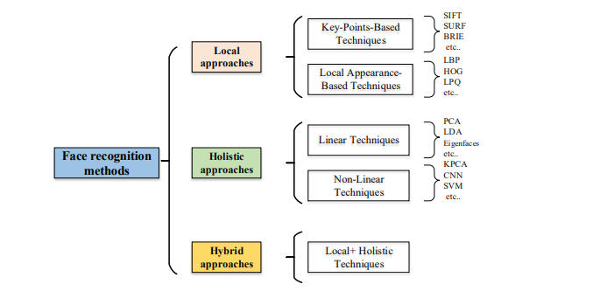
Figure 2.3 Kortli et al. (2020) Face Recognition Methods Classification
From Figure 2.3, Scale-Invariant Features Transforms (SIFT) and Scale-Invariant Features Transforms (SURF); Binary robust independent elementary features, or BRIEF for short, CNN, convolutional neural network; PCA, principal component analysis; LDA, linear discriminant analysis; KPCA, kernel PCA; LBP, local binary pattern; HOG, histogram of oriented gradients; LPQ, local phase quantization; Support vector machine, or SVM.

Hande et al. (2023) suggest that the facial recognition-based intelligent attendance system with the Raspberry Pi is an innovative solution that uses computer vision technology to automate the service process. This system records an individual's existence in a database by analysing and capturing face traits through the use of image processing algorithms and a camera module. An image of a person's face is fed into the system, which then compares it to a database of recognised faces. Once the input image and the stored face match, the recognition system recognises your presence. Numerous variables, including the number of students enrolled, the lighting, the quality of the camera, and the Raspberry Pi's processing capacity, might affect the performance metrics for a smart attendance system based on facial recognition. Hande et al. (2023) also suggested that the accuracy of recognition using the Raspberry Pi was over 90%. Al-Muhaidhri and Hussain (2019) also recommend utilising the Raspberry Pi. The face detection method was tested on several volunteers, and the findings showed a recognition accuracy of about 98.5%.

Bussa et al. (2020) suggest the use of OpenCV and local binary pattern histograms (LBPH) algorithms for face detection, feature extraction, and face recognition. Bussa et al. (2020) also suggest that LBPH algorithms have an advantage in that they are among the simplest face recognition algorithms; they can characterise local aspects of the images; they can produce notable results; and they can be implemented using the OpenCV library. Bussa et al. (2020) also suggest that more than 2500 sophisticated algorithms, including a wide range of both conventional and cutting-edge computer vision and machine learning methods, are available in the OpenCV package. These algorithms are useful for a variety of tasks, such as face detection and recognition, object identification, 3D model extraction, creating 3D point clouds from stereo cameras, stitching images together to create a high-resolution scene image, locating similar images from an image database, removing red eyes from flash-taken images, tracking eye movements, recognising scenery and adding markers to overlay it with enhanced reality, and more. Basthomi et al. (2019) suggest the use of LBPH algorithms based on the testing image using the viola-jones and LBPH algorithms, and from the research conducted, a 100-time test shows that the system can recognise faces as many as 93, so the success and accuracy are 93%.
In research conducted by William et al. (2019), research on FaceNet employs two pre-trained model types: VGGFace2 and CASIA-WebFace. The FaceNet approach is evaluated on a variety of widely used standard facial picture data sets. Based on the study experiment results, FaceNet outperformed other approaches and produced good outcomes. FaceNet can achieve near-perfect recognition accuracy on the YALE, JAFFE, AT & T datasets, Essex faces95, Essex grimace, 99.375% on the Essex faces94 dataset, and the lowest possible accuracy of 77.67% on the faces96 dataset when employing VGGFace2 pre-trained models. Alhananaee et al. (2021) suggest a deep learning-based facial recognition attendance system based on research conducted using convolutional neural networks, SqueezeNet, GoogleNet, and AlexNet, where they achieved recognition validation accuracy of 98.33%, 93%, and 100%, respectively. Shepley (2019) supports the application of a deep learning strategy. Based on Figure 2.4, the researcher proposes that from Haar characteristics to small, highly occluded faces Accuracy in face detection has greatly increased since convolutional neural networks (CNNs) were used.

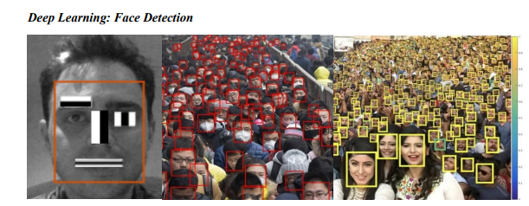
Figure 2.4 Shepley (2019) Deep Learning Face Detection

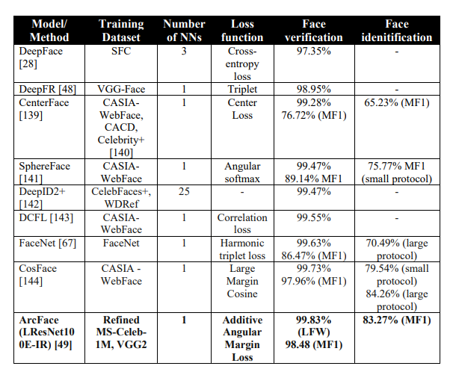
Table 2.4 Shepley (2019) Model comparison
Shepley (2019) compares competitive and state-of-the-art face verification and identification techniques using Table 2.4. Unless otherwise noted, every verification result is documented on the LFW dataset. The MegaFace Challenge 1 (MF1) dataset is used to obtain all identification results.

Challenges and Future of Face Recognition
Facial recognition is a cutting-edge technology that can change our future by assisting in the recovery of missing persons, preventing commercial theft, and enhancing security protocols. However, the introduction of this system into the system carries some dangers and implications, such as threatening privacy, imposing on personal freedom, and violating personal rights (Falalu et al., 2023).

Other techniques in Smart attendance systems.
Ahmad et al. (2021) suggest using radio frequency identification (RFID) and fingerprint reader applications in a student attendance management system as a two-factor verification system. Using radio waves to identify and monitor individuals or objects, RFID (Radio Frequency Identification) is the most advanced technology available. RFID uses the radio frequency region of the electromagnetic spectrum for wireless communication via electromagnetic and electrostatic interaction (Raghu et al., 2023). However, Qureshi (2020) suggests that the primary expense associated with installing the RFID reader hardware in every classroom and giving each student an RFID tag is the primary constraint of the RFID system. The suggested system has ongoing maintenance costs as well.

Moola et al. (2021) recommend employing iris, fingerprint, and ear biometrics for newborn biometric identification to track children's attendance. According to the research, ear biometrics may be easily learned from birth, and algorithms designed for adult ears can also be applied to the ears of infants. Iris biometrics can correctly match people as early as six weeks, and as kids get older, the acquisition rate gets better. However, Harakannanavar et al. (2019) suggest that there are numerous obstacles to iris detection, including small targets that are difficult to detect from a distance, involuntary, obstructed by lenses, eyelashes, and reflections, and partially hidden by eyelids, eyelashes, and shadows.

Research Gap
- As shown by the literature, smart attendance systems based on face recognition have significant promise as the number of improved and quality algorithms increases. However, after going through all the papers, the researcher realised the following gaps and opportunities: Scalability and accuracy: Research indicates that many existing systems are limited in their ability to scale to large numbers of users. Most facial datasets used to test certain algorithms were limited. Face recognition algorithms can be prone to errors, particularly in situations where faces are partially masked or where there is poor lighting. Privacy: There are growing concerns surrounding the usage of facial recognition technology, particularly for sensitive applications such as attendance tracking, as it has the potential to be misused and infringe on privacy rights. Face recognition systems typically collect and store biometric data, such as facial images and scans, and this can raise concerns about how this data is collected, used, and stored and how it may be accessed by unauthorised individuals. Usability: The user experience of many existing systems is often not optimal, with poor user interfaces and limited features. From the literature reviewed, many systems do not have a significant reporting method. There is a need to have a system that provides an interactive dashboard reporting attendance status and duration of attendance. Many systems do not allow for customization, such as the ability to set up individual user profiles or to customise the system for specific use cases.

Proposed Solution
From the literature reviewed, the most used frameworks were deep learning and computer vision, which have shown high recognition accuracy. The researcher agrees more with the study conducted by William et al. (2019) because, from the different large databases tested, a combination of deep learning and computer vision approaches showed high recognition accuracy that ranged from 99.375% to 100%. suggest that there are numerous obstacles to iris detection, including small targets that are difficult to detect from a distance, involuntary, obstructed by lenses, eyelashes, and reflections, and partially hidden by eyelids, eyelashes, and shadows. The researcher's goal is to use face recognition technology to create an intelligent attendance system that combines computer vision and deep learning techniques. This technology will make student attendance monitoring more precise and efficient. The researcher also concurs with Wanyonyi & Celik (2022) that Insightface can be easily utilised to create a full-production face recognition system because it offers a straightforward API and sample scripts for face recognition testing. Therefore, the researcher will implement the system using the InsightFace model and integrate it with other tools such as the OpenCV library, Pandas, and NumPy to carry out image processing, data manipulation, analysis, and processing. The system should be able to generate reports and should have data security rules set to ensure authentication and authorization. Users should be able to use the system easily and trust it. The researcher seeks to use a distributed architecture as a way to ensure load balancing and improve scalability and performance. Furthermore, the researcher seeks to utilise Python libraries to provide real-time image processing, automatically identify individuals, whether individually or collectively, and streamline the process of monitoring student attendance.

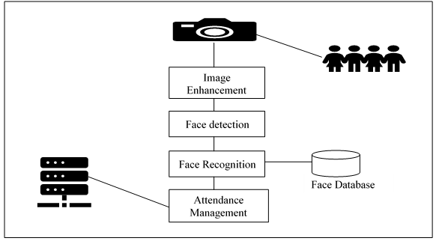
Figure 2.5 Proposed Experiment Setup

Conclusion
The conducted systematic literature review identified the available techniques for face recognition implemented on smart attendance systems. Other smart techniques, such as RFID, adopted in different smart attendance systems were also discussed, giving an outline of how effective they are and how they assist different stakeholders. As a result, the researcher discovered that there are limited smart attendance systems designed specifically for the nursery age group. Furthermore, the researcher identified the need for further investigation of smart attendance information reporting and alerting strategies. The researcher then proposed a solution to cover the identified gaps, which would lead to better automated, secure, consistent, and streamlined monitoring and recording of student attendance.

Methodology

Introduction
Research methodology is the path through which researchers need to conduct their research. It shows the path through which these researchers formulate their problem and objective and present their results from the data obtained during the study period (Sileyew, 2019). This chapter highlights and justifies potential research approaches, data science, and software development methodologies for the system under study that could be applied to the creation of the web application.

Research Methodology
In this section, the researcher discusses the research methodology that was employed in the study. To achieve the research aim, it was necessary to conduct an appropriate research methodology that would enable the collection of relevant data and facilitate the development of the system to achieve the research goals. The chosen research methodology for this study is mixed-methods research.

Mixed Methods Research:
A mixed-methods study involves combining quantitative and qualitative data gathering and analysis techniques in a single study. It can be utilised at any point during the development of a digital product or service. In this research, the researcher used an open-source, pre-trained model. The researcher used a quantitative approach for data analysis and processing of the data obtained from the pre-trained model. During data preparation, data was converted to numerical format using the NumPy library, and the Pandas library was used to create data frames and visuals for analysis. A qualitative approach was then used to develop the system. Observations at a local daycare centre were done by the researcher to explore the depth and complexity of children's behaviour and interactions in a classroom. A visual analysis of classroom images was also done by the researcher to understand the concept of camera localization. The researcher carried out all these activities to come up with an optimal solution and resources.

Alternatives
Several other research methodologies could have been used in this study. One alternative method that could have been used is case study research. This approach entails a thorough examination of a single case, which may have been a particular smart attendance system for a particular nursery school. This would have enabled a detailed analysis of the system and its performance.

Another alternative method that could have been used is experimental research. This method involves the manipulation of variables to observe the effect on the outcome. This might have been used to assess how well different methods for face detection and recognition performed.

Justification of Mixed Methods Research
From the literature reviewed, different research approaches were used. The researcher agreed a lot with many findings from Hande et al. (2023) and Bussa et al. (2020), who used a mixed-methods approach and were able to get recognition accuracy that was over 95%. Mixed-methods research can provide a more comprehensive understanding of classroom attendance management. The researcher believed that integrating different methods could help mitigate errors and improve the quality of the system.

Data Science Methodology
In this section, the researcher discusses the methodology used in this study on image processing, data processing, model configuration, and building a fast face recognition archetype. The researcher used the methodology named the Cross-Industry Standard for Data Mining (CRISP-DM). Additionally, the researcher will provide a detailed explanation of how the CRISP-DM methodology was implemented, its dominance, and its limitations for this study. Finally, the researcher will compare this methodology with other techniques and methodologies that can be used for building a face recognition model and justify the choice of using CRISP-DM.

Cross-Industry Standard for Data Mining (CRISP-DM)
Hotz (2023) suggests that CRISP-DM is a process model that serves as the basis for a data science process. The researcher carried out CRISP-DM steps in an iterative manner to mitigate errors and improve functionality as a way to come up with an optimal solution. CRISP-DM provides a structured and agile way of conducting data science practices, and this was beneficial to the researcher because it allowed room for continuous improvement and modifications.
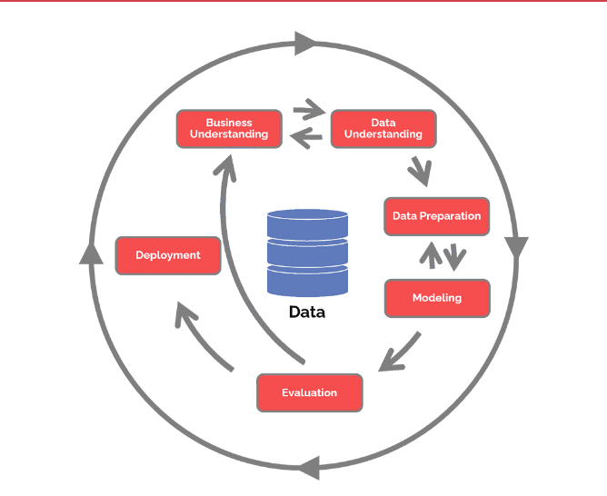
Figure 3.1 Hotz (2023) CRISP-DM Steps
Business Understanding
During this stage, the researcher tried to understand the business value of the proposed system and how it would be useful to teachers and students. The researcher identified the stakeholders, defined the project objectives, and developed a clear understanding of the problem or opportunity at hand. The researcher came up with a business problem that defined the need for automation of students’ attendance monitoring using face recognition to streamline the process and reduce administrative costs.
Data Understanding
During this stage, the researcher gathered the data by capturing images of children using a smartphone. The researcher got approval from the children’s guardians. The researcher's main goal during this stage was to have a comprehensive understanding of data formats, quality, and pixel arrangement to effectively apply the fast face recognition model. Images were also obtained from open-source datasets such as Kaggle and ImageNet. The researcher used the Python library OpenCV for image processing to understand the colour or grey scale representation of the image's pixels and the array representation of the image.
Data Preparation
The researcher carried out three major tasks, namely, data cleansing, feature engineering, and feature selection. During data cleansing, the researcher identified and corrected errors in the data, such as duplicate records and inconsistent formatting. The researcher used the OpenCV library to trim images to enable fast and easy feature engineering. During feature engineering, the researcher created new features from the existing data, which were used to improve the accuracy of the dataset. During feature selection, the researcher chose a subset of features that are most relevant to image analysis. Features such as eyes, the shape of the nose, the shape of the mouth, and the chin were selected. Cleaned data was placed in a directory.
Modelling
During this stage, the researcher worked with the pre-trained model. The researcher used samples of images from the cleaned data's directory and applied them to the Buffalo_sc Insightface model. The model was able to detect facial embeddings, facial key points, detection scores, and bounding boxes from the images. The researcher used NumPy to convert the array of data to a num_array, which is easy to manipulate. Pandas were then used to convert the num_array to a data frame to clearly understand the data points. The researcher then configured the model with the computer device to test for real-time detection and feature extraction. The model was able to detect and extract key facial embeddings from the live stream image frame. This process was done iteratively with different parameters until an optimal model configuration was found.
Evaluation
During this stage, the researcher evaluated the model to determine whether it met the research objectives. The researcher evaluated if the model was able to detect images, extract features, and recognise them. The researcher evaluated the accuracy metrics and business metrics to identify any shortcomings of the model and provide feedback for future iterations of the model.
Deployment
This is the final stage carried out by the researcher to deploy the model into production and integrate it with the Redis database. The researcher configured the model to connect to the Redis database. The researcher created an algorithm that posts extracted facial features' data to the Redis database. Redis was used for in-memory data storage to power live streaming use cases.

Dominance and Limitations of CRISP-DM to the study
Dominance:
- CRISP-DM provided a straightforward set of steps to follow, which were easy to comprehend.
- CRISP-DM allowed the researcher to create a fast face recognition archetype that fitted the researcher's particular needs.
- The researcher was able to create an optimal archetype in a reasonable timeframe.
Limitations:
- The methodology did not explicitly address issues such as data privacy and security.

Alternatives
Several other data science methodologies could have been used in this study. The researcher could have used SEMMA (Sample, Explore, Modify, Model, Assess), Knowledge Discovery in Databases (KDD), and Foundational Methodology for Data Science (FMDS) for modelling.
KDD
KDD (Knowledge Discovery in Databases) is a methodology for extracting knowledge from large volumes of data. It consists of five phases: selection, pre-processing, transformation, data mining, and interpretation and evaluation. One advantage of KDD is that it has a clear and well-defined process for data mining and analysis. However, one disadvantage is that it can be time-consuming and resource-intensive. There was limited literature that used KDD in the literature reviewed by the researcher.
SEMMA
SEMMA stands for sample, explore, modify, model, and assess. SEMMA was developed by the SAS Institute. SAS uses SEMMA to methodically organise the functions of its statistical and business intelligence software (Wiemer et al., 2019). It consists of five phases: sample, explore, modify, model, and assess. The first phase involves selecting a representative sample of the data, while the second phase involves visualising the data and identifying relationships between variables. In the third phase, the data is cleaned and transformed as needed. The fourth phase involves building a predictive model using a variety of algorithms, and the final phase involves assessing the accuracy and reliability of the model. One advantage of SEMMA is its flexibility and versatility. It can be used with a variety of data types and can handle large volumes of data. Additionally, the use of multiple algorithms in the modelling phase can lead to more accurate predictions. However, one disadvantage is that it can be time-consuming and resource-intensive, especially in the model-building phase. There was limited literature that used KDD in the literature reviewed by the researcher.
FMDS
The Foundational Methodology for Data Science (FMDS) provides a structured framework for tackling intricate problems inherent in data science projects (Hassani et al., 2020). The researcher could have used the power of the FMDS methodology to construct a face recognition model. Business knowledge, analytical approach, data requirements, data collection, data interpretation, data preparation, modelling, assessment, deployment, and feedback are some of the steps that make up the FMDS process. By following these steps, a researcher could build a fast face recognition framework. However, FMDS is a data-driven approach that uses statistical and linguistic techniques. It is more suitable for textual analysis by extracting the most important information from the text. There was limited literature that used KDD in the literature reviewed by the researcher.

Justification of using CRISP-DM methodology
The CRISP-DM methodology is a structured approach to data mining that helps manage the complexity of a project and increases the chances of success. It breaks down the data mining process into specific phases, from initial understanding of the business to final deployment. The approach is iterative, allowing for frequent evaluations of the project's progress against its objectives. The researcher chose to use CRISP-DM to minimise the risk of reaching the end of the model configuration and finding that the research objectives have not been met. The methodology can also be customised to meet specific requirements and adapted to different domains.

In contrast to other methodologies, such as KDD and FMDS, CRISP-DM is more ideal because FMDS is designed specifically for text summarization and KDD does not provide a clear structure to develop a model. It is a reliable and consistent approach that has been refined over several decades of research and development. By using CRISP-DM, we can be confident that we are applying a proven and effective methodology for configuring the face recognition model and building a fast face recognition system archetype.

Software Development Methodology
In this section, the researcher discusses the methodology used in this study on the agile development of the smart attendance system, namely Scrum. Additionally, the researcher will provide a detailed explanation of how the Scrum methodology was implemented, its dominance, and its limitations for this study. Finally, the researcher will compare this methodology with other techniques and methodologies that can be used for developing smart attendance systems and justify the choice of using Scrum.

Scrum
The researcher carried out the following steps suggested by Lee & Chen (2023) Figure 3.2 below to carry out the iterative agile system development.
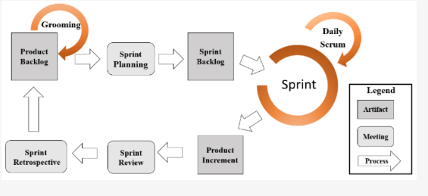
Figure 3.2 Lee and Chen (2023) Scrum Methodology
Product Backlog
The researcher acted as the product owner and created product backlogs, which are the master list of all functionality desired in the product. The product owner then described the top items to be tackled. The researcher acted as the team, and the research supervisor acted as the scrum master to determine which items could be completed during the coming sprint.
Sprint Planning
The researcher started a sprint, which is a fixed-duration work cycle of one month or fewer. It is during this time that concepts are given value. To begin, the researcher listed all of the tasks that needed to be completed for the sprint. The following queries were posed to the researcher in order to efficiently design the sprint:
- Why is this Sprint valuable?
- What can be accomplished in this Sprint?
- How will the selected work get done?
The researcher offered suggestions on how the product may improve in value and utility for the current Sprint in his capacity as the product owner. Next, taking on the role of the developer, the researcher chose which items from the product backlog belong in the current sprint. The developer (researcher) scheduled the work necessary to produce an increment that satisfies the definition of done for each chosen product backlog item. The product backlog items were divided into smaller work items that could be completed in a day or less.
Sprint Backlog
The researcher created a list of work items planned to be completed during a project sprint. These items were pulled from the product backlog during the sprint planning session.
Sprint
During this stage, the researcher carried out the events of the project, whereby the idea was turned into value. There was the prototyping and designing of the system. There was the development of the system based on the sprint backlog. The researcher utilised short iterations for feedback to inspect and adapt both the process and the product. Daily scrum meetings were held to keep track of the sprint backlog. The researcher evaluated what had been achieved in the previous daily scrum.
Product Increment
During this stage, the researcher looked to see if the product was in a deliverable state. The product owner decided whether it should be delivered. The researcher ensured that the product was in a deliverable state and thus met the definition of done. There was integration, testing, and deployment of all the deliverables.

Sprint Review
During this stage, the researcher carried out a collaborative meeting that is typically held at the end of every sprint. The researcher went through work items completed during the sprint or iteration. The researcher ensured that key stakeholders (supervisor and research board) were up to date, and this enabled them to provide feedback.
Sprint Retrospective
In this stage, the researcher conducted a retrospective meeting to review the previous sprint and identify areas that went well and those that need improvement. These meetings were crucial in ensuring that the project sprint process was improved continuously and that any key learnings were incorporated into the next sprint.

Dominance of Scrum and its Limitations to the Study
The following leads were obtained by using Scrum in this study:
- The researcher was able to complete project deliverables quickly and efficiently
- Scrum was able to break down the complexity of the research thereby allowing the researcher to easily manage the project through sprints
- Scrum ensured effective use of time and money during this research
- Scrum ensured adaptability and flexibility development
- Scrum methodology increased the motivation and satisfaction of the researcher.
- Scrum methodology prompted room for continuous feedback which enabled the researcher to identify and fix errors.
The following are the limitations of Scrum to the study:
- There was a high risk of goal misalignment since the product backlog and sprint backlog were created based only on the experience of the researcher.
- Scrum did not apply to some parts of the development that had multiple dependencies.

Software Development Methodology Alternatives
In this study, several other software development approaches may have been applied. The system development might have been completed by the researcher using Extreme Programming or Rapid Application Development (RAD).
Rapid Application Development (RAD)
To swiftly deliver functional software to clients, the Rapid Application Development (RAD) methodology emphasises quick prototyping and iterative improvement cycles. The RAD methodology emphasises collaboration between developers and customers and focuses on delivering software in small, manageable increments. The methodology also incorporates automated tools and techniques to speed up the development process. One of the main benefits of RAD is the ability to quickly deliver working software to customers. This can help reduce time-to-market and improve customer satisfaction. RAD is also well-suited for projects with rapidly changing requirements or tight deadlines. The researcher could have implemented this methodology to carry out iterative development and prototypes. However, the main disadvantage of this methodology is the lack of iterative feedback. In RAD, the development process is divided into different phases, and once a phase is completed, it is not revisited. On the other hand, Scrum allows an iterative development process, so there is continuous feedback and improvement throughout the process. The researcher chose Scrum over RAD because of the iterative process of Scrum, which allows problems to be identified and addressed early, reducing the overall cost and time to completion.
Extreme Programming
The Extreme Programming (XP) methodology is an agile approach to software development that places a focus on communication, criticism, and quick iteration. The previous software development approaches' rigidity and inflexibility prompted the introduction of XP in the late 1990s. The basic principles of the XP technique are communication, simplicity, feedback, and courage. The approach places a strong emphasis on open lines of communication and teamwork between developers and clients, to provide functional software as soon as feasible. The XP methodology's ability to swiftly provide functional software to consumers is one of its primary advantages. Customer satisfaction can increase, and time to market can be shortened as a result. The researcher could have implemented Extreme Programming as a system development method, placing a focus on communication and quick iteration. However, XP focuses a lot on technical practices such as pair programming and continuous testing, which can be time-consuming and difficult to implement. The researcher chose Scrum over XP methodology because of the flexibility of Scrum, which allows the implementation of technical practises to be adapted to the specific needs of the project.

Justification for Scrum as the chosen Software Development Methodology
The iterative process of scrum enables problems to be identified and addressed early, reducing the overall cost and time to completion. This is why the researcher chose scrum over other methodologies. Scrum methodology allows continuous feedback and adaptation, which is necessary for building a smart attendance system. Scrum methodology is highly flexible, which is important for a project that is subject to change, like a face recognition system.

Development Tools Required
- Programming languages: Python.
- Web app development framework: FastAPI - it is easy and flexible to work
with data projects
- Front-end framework: Streamlit – implementation is easy and builds beautiful
interfaces
- InsightFace Face recognition library – It has high face recognition accuracy
- OpenCV and NUMPY – best libraries for numerical calculation and image processing
- Database management system: Redis – it uses a format of cache memory
which provides data fast and will be very compatible with the application
since it requires a swift response of data.

Conclusion
In conclusion, selecting the right methodology for face recognition model configuration and smart attendance system development is critical for the success of a project. While there are several data science approaches available, including KDD, SEMMA, and FMDS, CRISP-DM is a well-established and effective methodology for configuring a face recognition model. Scrum is the best methodology approach for system development because it is more flexible to implement. Additionally, Scrum allows an iterative approach, which results in continuous feedback and adaptation.

System Analysis and Design

Introduction
This chapter focuses on analysing and designing the facial recognition-based smart attendance system. The system analysis phase contemplates a thorough investigation of the system components and how these components interact with one another to facilitate information communication. Use case diagrams, sequence diagrams, flowcharts, and other UML diagrams to visualise the system's functional and non-functional needs throughout the design phase.

System analysis
The facial recognition-based smart attendance system is composed of several components, which include a frontend user interface, serverless backend microservices, and a trained face detection model. These components are capable of independent functioning, with the front-end user interface responsible for user interaction and data capture, various backend microservices processing all user requests made from the front end, and the trained computer vision model responsible for facial detection.

Requirements Specification
Requirements specification defines what a system should do, what services it should provide, and what characteristics it should possess. Hence the researcher classifies the requirements specification into two categories: functional and non-functional requirements.

Functional Requirements
The proposed system should be able to:
- Authenticate all system users
The system should be able to authenticate all system users (administrators, teachers, and parents) to ensure that only authorised users can access the system based on user permissions and roles. The system has reports about students, teachers, and also data about facial features, which is confidential and should only be accessible to authorised personnel. Therefore, authentication is a crucial requirement as it helps ensure the protection of confidentiality.
- Detect and recognize faces from the video frame in real-time
The system should detect and recognise faces in real-time to ensure the accuracy and reliability of the attendance reports. Real-time monitoring allows for instant monitoring of attendance status, and teachers or supervisors can see who is present or absent at any given moment, enabling timely interventions if needed. Real-time monitoring can provide valuable data insights over time, such as attendance patterns, trends, and analytics. This data can be used for improving resource planning, identifying attendance issues, or optimising scheduling.
- Record attendance and grant authorized users the privilege to view attendance reporting dashboards.
Recording attendance can help teachers or parents systematically track children's presence or absence. This data is also essential for monitoring attendance trends and addressing any issues related to attendance compliance.
- Allow admin users to carry out scheduled system maintenance.
Allowing admin users to carry out scheduled system maintenance is essential for ensuring the reliability, security, and performance of the system. Admin users can implement security updates and patches during scheduled maintenance to address vulnerabilities and protect the system from potential cyber threats. This is crucial for maintaining data integrity and safeguarding sensitive information, such as facial feature data.

Non-Functional Requirements
Non-functional requirements describe requirements that guarantee a system’s quality. These are classified under the different categories discussed below.
- Security and Privacy
The system should be highly secure and make use of cross-site request forgery tokens and password hashers to maximise the security of the system. Each user is assigned a specific role, which gives them the privilege to access system features. The three main roles in the system are the admin role, the teacher role, and the guardian role. Mechanisms for individuals to access information about how the system is collecting and using their data should be transparent and clearly defined.
- Reliability
The system should experience minimal to zero downtime due to an optimal system architecture. Data should be available all the time, and the system should be able to perform regular backups. Identification and repair of malfunctioning system components should be conducted seamlessly without affecting the rest of the system.
- Operational Excellence
The system should achieve operational efficiency by employing a DevOps approach and deploying it in an AWS cloud production environment. Overall, running and monitoring the system should be easy and efficient.
- Performance Efficiency
With the system deployed on the cloud and using Redis as a database, system operations and task executions should be achieved at lower latencies. This ensures that users get quicker responses to requests made through the front-end user interface.

System Design
The system design acts as the blueprint of the software system, defining the structure and interactions between different system components. When choosing the system architecture, the researcher considered factors like scalability, performance, reliability, extensibility, maintainability, and factors stated in the non-functional and functional requirements to come up with the best system design. The researcher iteratively designed the system, following the principles of good system design. The researcher kept the design as simple as possible to move complexity to infrequently used parts of the system. The researcher used every effort to create an architecture design that facilitated flexible and easy user interaction because the primary objective of developing the facial-based smart attendance system was to expedite the process of recording attendance and provide timely reports that can be used to make data-driven decisions.
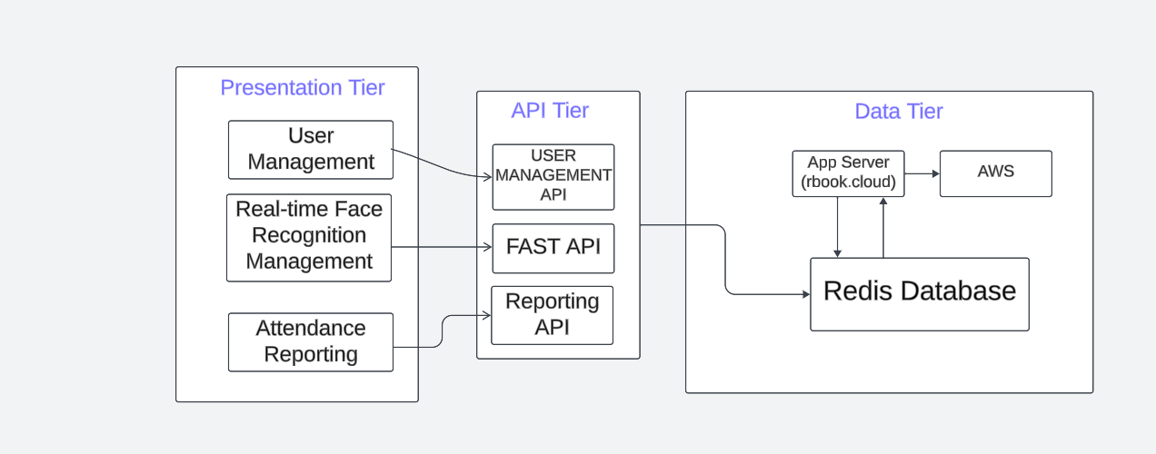
Figure 4.1 System Architecture
As indicated in Figure 4.1, the system follows a three-tier architecture, with system components developed incrementally and possessing the ability for independent function. This type of system architectural design promotes easier debugging and the reusability of the system components. Ultimately, these components are integrated to form the desired face recognition system. The following sections discuss each of these components in detail.

User Management (Client Application)
The client application exhibits the designed frontend user interface, which acts as the main point of user interaction with the system. It provides a platform for data capture and making requests to the backend microservices. The user interface allows system users to perform various activities, best represented using a use case diagram.
Use Case Diagram
Use cases are high-level system processes portrayed in a structured manner. It comprises a set of possible sequences of interactions between the system and its users in a specific environment and with a specific goal. In this research, the researcher identified three main types of system users: admin users, guardian users, and teachers. These three users interact with the system differently based on the roles assigned in the access management component of the system. These users, however, share common interactions with certain features or functionalities of the system.
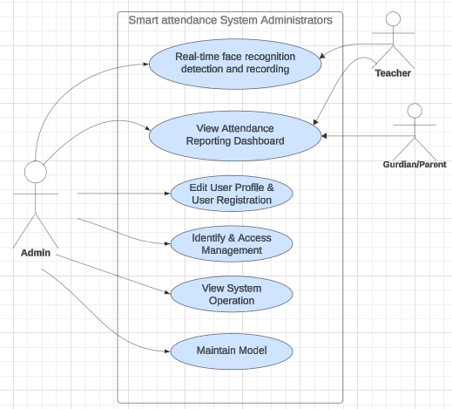
Figure 4.2 Use Case Diagram
Figure 4.2 above illustrates the use case diagram for the face recognition-based smart attendance system (System Administrators).

User Identity and Access Management
Identity and access management proved to be a key component of the proposed system to classify users as either administrators or general users carrying out general tasks assigned to their view. Hence, Streamlit Authenticator, an open-source authentication library, was implemented and integrated with the system to provide the following functionalities:
- Authenticating all system users.
- Providing single-sign-in and user session management.
- Creating user groups and assigning roles to each group granting either admin or general employee access to the system
- Adding users to either one of the groups
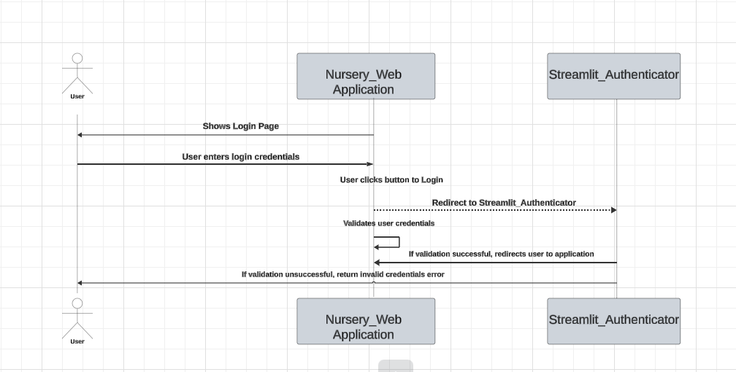
Figure 4.3 User Authentication Sequence Diagram
Figure 4.3 above presents a sequence diagram indicating the integration between Streamlit Authentication and the client application.

Real-time Face Recognition Inference and Attendance Reporting
System administrators or teachers initiate the real-time face recognition process by clicking on a button that allows communication between the different components of the system, such as the web real-time communication (webRTC) library that allows the use of a webcam camera. The InsightFace model detects a person from a real-time video frame and extracts key facial features. These extracted facial features are then compared with the key features stored in the Redis database using a cosine similarity machine learning algorithm. Time and date modules are also triggered to record the time of the detected faces. Once the teacher or administrator is satisfied, he or she can stop the real-time face recognition recording by simply clicking the stop button. If the teacher clicks stop, the webRTC function is then terminated. The name of the person, time, and date of detection are saved as logs. These logs are used to create the best interactive attendance reports. Finally, the user clicks the stop button to stop the inference process, and the attendance reporting will be ready for view. All users have access to view certain attendance reports. To view the report, users can click the button for written attendance reports on the system tab and select attendance reports. The report should contain the name, role of the person, time and date of detection, and attendance status, which can either be present or absent. All unknown faces are discarded from the report. Users should be able to download the report by simply clicking a button, and a copy will be saved on the local machine. Figure 4.4 below best explains the real-time face recognition recording.

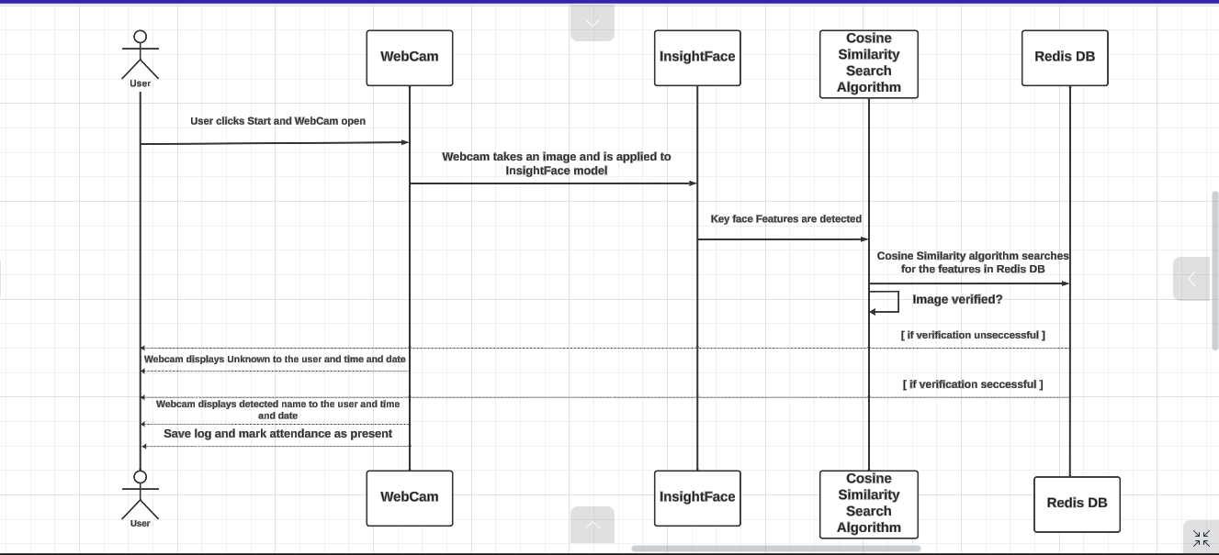
Figure 4.4 Real-time Face Recognition Inference Sequence Diagram

Fast Face Recognition Model
A trained InsightFace buffalo_sc model acts as the backbone of the reporting process described in Figure 4.4. It is the component responsible for detecting faces in a video frame, extracting key facial features, and saving or searching those features in the database. Before choosing insightface buffalo_sc as the trained model of choice, the researcher performed a series of experiments on other versions of the insightface family of models, buffalo_l and buffalo_m. This was to ensure that the model producing high-accuracy face recognition results and optimised space was chosen. Figure 4.5 below best explain the fast-face model process management.
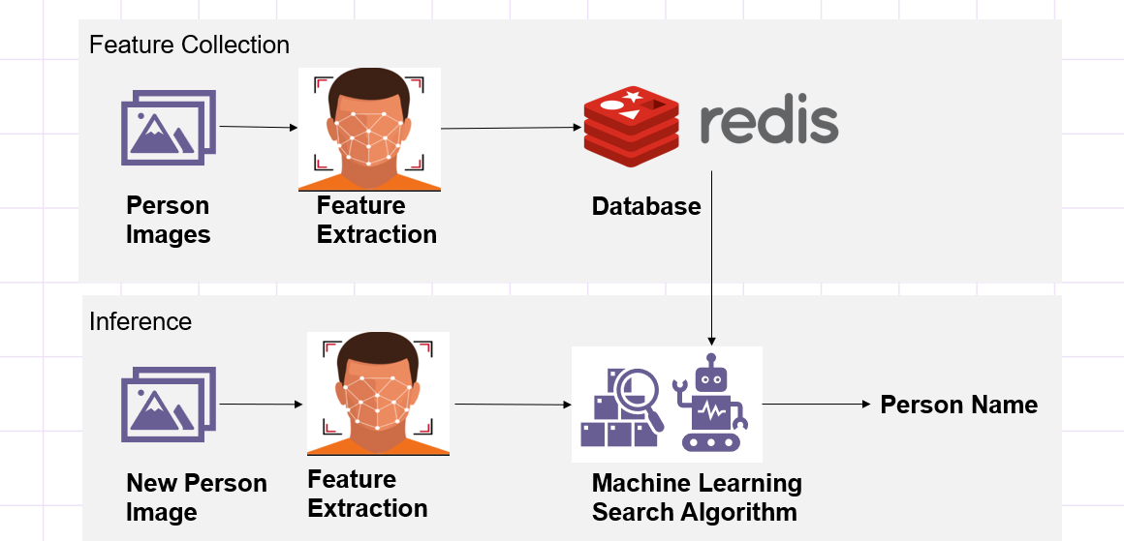
Figure 4.5 Fast Face Recognition Model Process Management Diagram

Redis Database Design
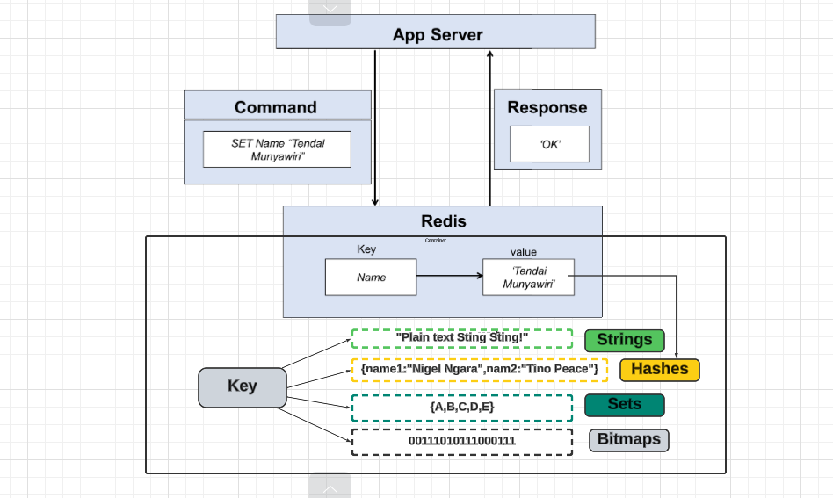
Figure 4.6 Redis Database Structure
Figure 4.6 above explain how data is saved in the Redis database hashes from the application. The database design defines the blueprint structure for how data is processed by the different system components and organised in a database. Redis Database was chosen to save samples of the facial embeddings of the registered user because of its fast caching memory, which makes it fast to retrieve data. During the registration phase, data is converted to a NumPy array, which is easily converted into the Redis database HashMap.

Conclusion
This chapter focused on the analysis and design of a smart attendance system using a facial recognition system. The researcher identified both functional and non-functional requirements required to build an effective system capable of achieving all the defined objectives. To emphasise and clarify the requirements analysis and design of the system, a use case diagram, a UML activity diagram, and architectural diagrams were utilized. These diagrams provided a transparent diagrammatic representation of the system, indicating how users interact with the system and how the data flows from one component to the next.

Implementation and Testing

Introduction
This chapter delves into the implementation and testing of the proposed system, transforming the conceptual designs discussed in the previous chapter into a functional system that meets the overall project objectives. In alignment with the Scrum methodology, the implementation process progresses based on the sprint backlog developed during the sprint planning phase. This chapter gives details on how each system component was built, tested, and validated. It also highlights how industry-standard patterns for data management and information exchange between system components were utilised to facilitate seamless integration.

System Implementation
The proposed facial recognition-based smart attendance system follows a microservice infrastructure. This facilitated the individual and iterative development of the system components, with the researcher having enough flexibility in choosing the component to develop first. The development of each of these components is discussed below.

Model Configuration
The Python programming language was used to configure and test the Buffalo_sc Insightface model for fast face analysis and recognition. The figure below shows the code of the model configuration.
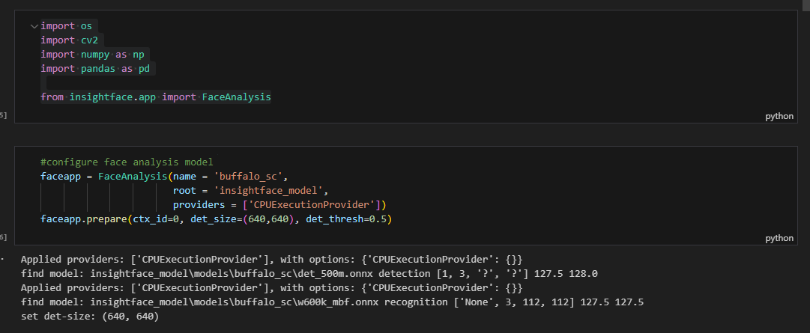
Figure 5.1 Model Configuration
Figure 5.1 shows the result of the successfully configured model. The ONNX Runtime Execution provider was also installed to allow the model to smoothly interact with the hardware components of a CPU.

Model Testing
The researcher created a dataset with at least ten samples of each person to use to test if the model is working correctly. Figure 5.2 below shows the loading of the image file path to the model and the extraction of facial features.
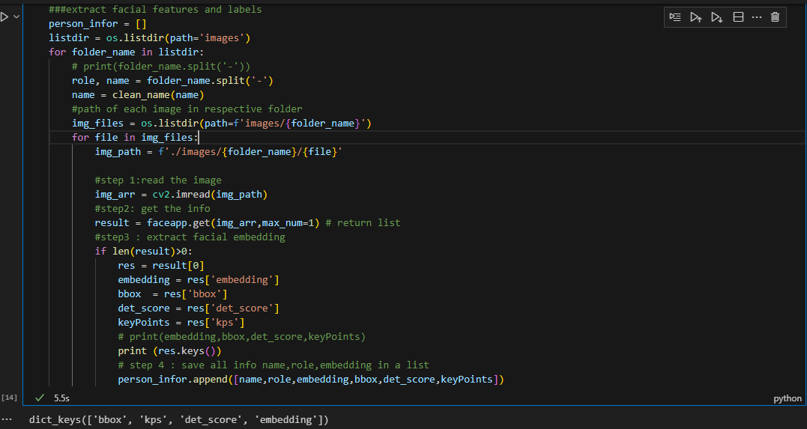
Figure 5.2 Images loading to the model
From Figure 5.2, we can see that the model can detect the bounding box, key points, detection score, and facial embeddings of images. The researcher created a data frame for a better view of the results from the model. Figure 5.3 below shows the data frame.
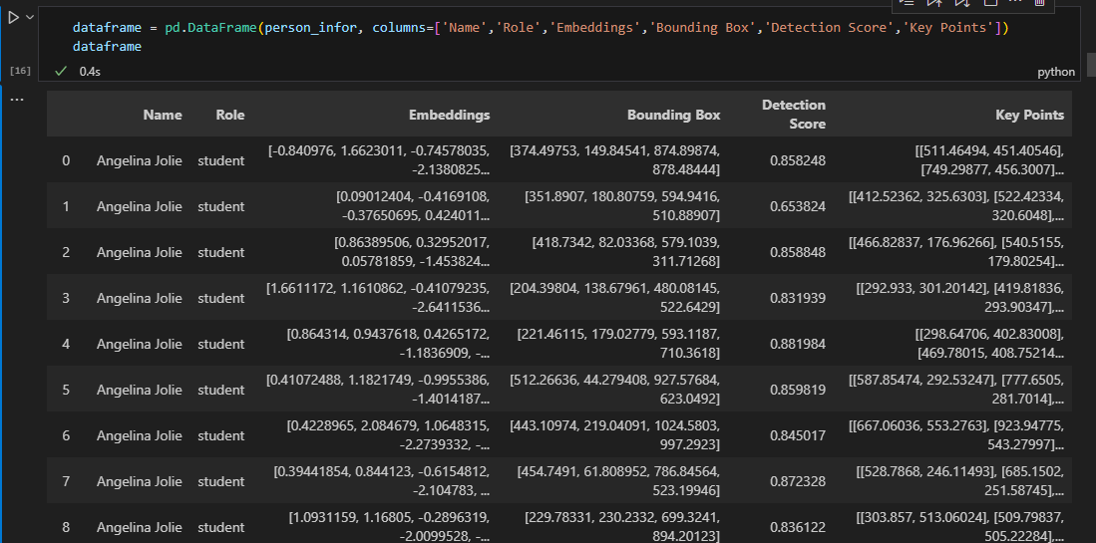
Figure 5.3 Facial Features Results Data Frame Snippet

Streamlit and Web Real-Time Communication Configuration
The researcher used Streamlit as the framework for the web application. Figure 5.4 below shows the configuration of Web Real-Time Communication to support real-time communication and enable the web application to capture video or image media.
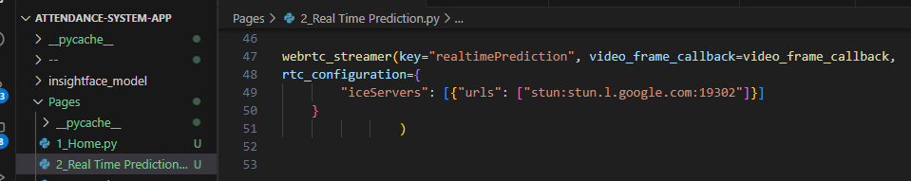
Figure 5.4 WebRTC Configuration

Real-time Detection and Facial Features Extraction
The model was configured to work with Streamlit Web Real-Time Communication to capture images from the video frame and extract facial features. To show the visibility of the extraction of facial features, a computer vision library (OpenCV) was used to do image processing. The OpenCV library was used to draw the bounding box, facial key points, and facial embeddings extracted from the video frame.
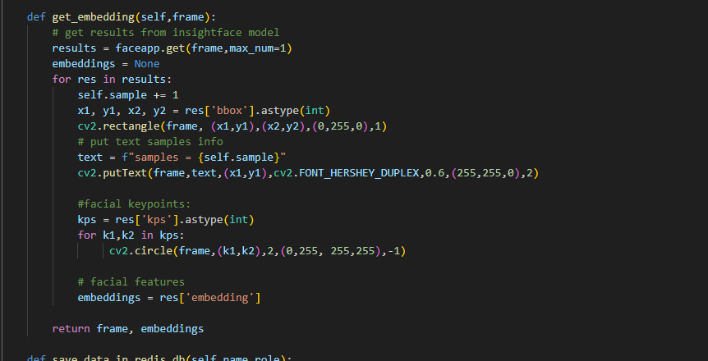
Figure 5.5 Computer Vision Image Processing
Figure 5.6 Real-Time Detection
Figure 5.5 shows the function that was created to extract facial features from the video frame. The OpenCV library carries out the live image processing to show the visibility extraction of these facial features by drawing a visible green rectangle on the face's bounding box detected. Small circles are also drawn on the facial key points detected, and a text showing the incremental number of samples being collected is also displayed. Figure 5.6 shows the function of the real-time video inference and the calling of the function to collect facial features. Figure 5.7 below shows the output of the real-time detection.
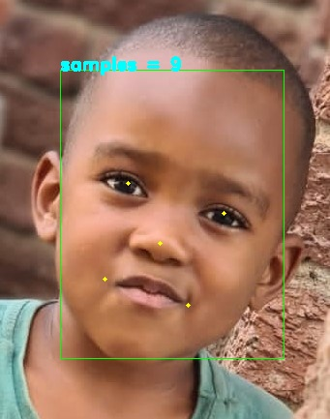
Figure 5.7 Real-time Detection Output

Redis Database Configuration and Saving Extracted Facial Features
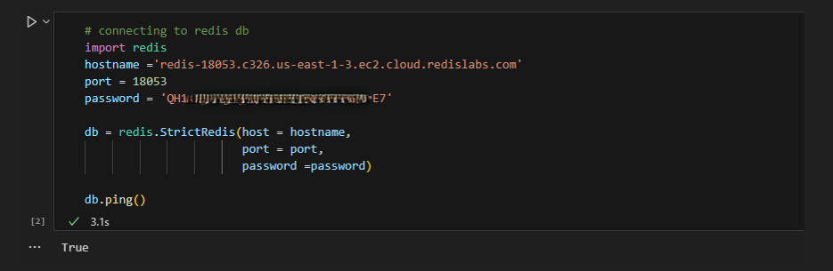
Figure 5.8 Database Connection
After the collection of facial features, there is a need to save the extracted features to a database. The researcher integrated the Redis cloud database into Python to save extracted facial features. Figure 5.8 shows the connection of the Redis database to Python. Figures 5.9 and 5.10 below show the function created to save the name, role, and facial embeddings of the person detected from real-time detection.
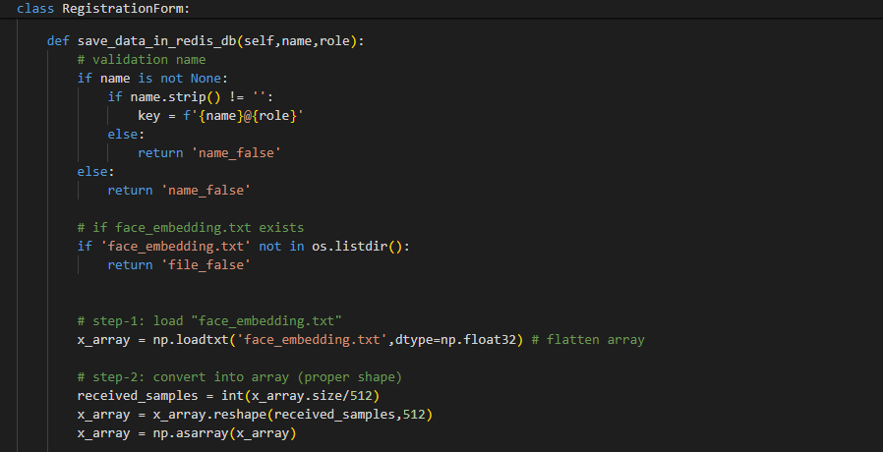
Figure 5.9 Saving data to Redis database code snippet
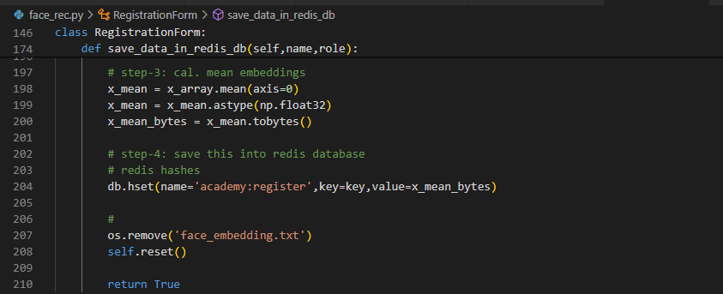
Figure 5.10 Saving data to Redis database code snippet

Real time-Prediction and Machine Learning Search Algorithm
The researcher created a function for real-time prediction as people interact with the system. The system uses the fast face recognition model, whereby the model takes the facial features of the face detected and uses a machine learning search algorithm to compare them with the saved features in the Redis database and make a prediction. The researcher compared the distance search algorithm (the Euclidean distance algorithm) and the similarity search algorithm (the cosine similarity algorithm).
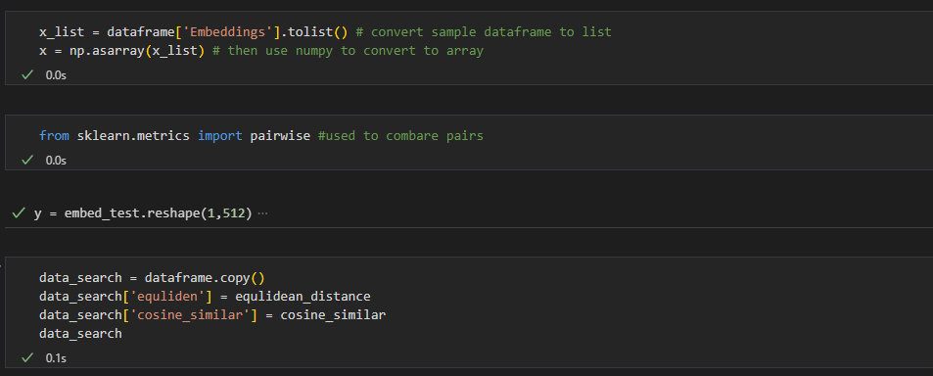
Figure 5.11 Cosine Similar and Equlidean Comparison Code snippet
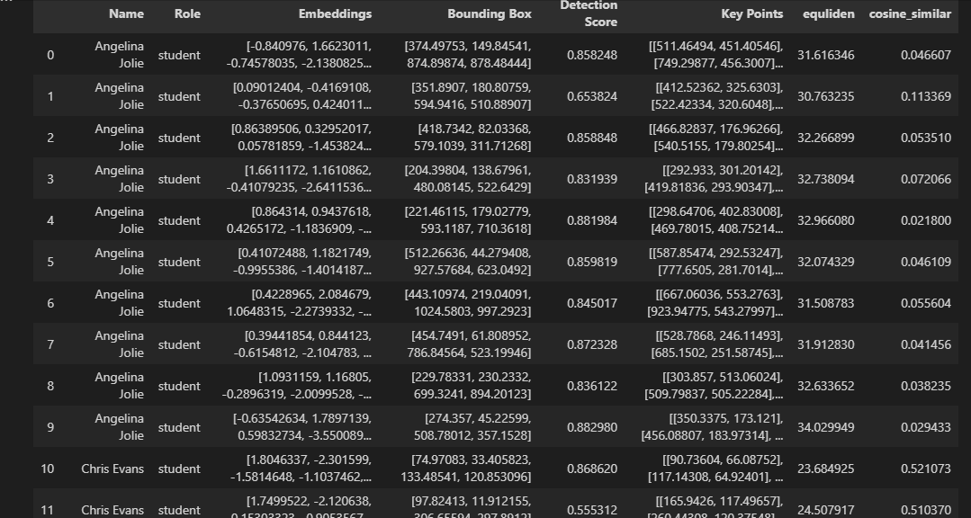
Figure 5.12 Data frame showing Results from the algorithms
Based on the analysis done on the data frame Figure 5.12, Euclidean results can be any number, and cosine results are numbers within the range of zero to ten. The attribute for optimal distance is chosen by the user; there is no standard optimal distance for the Euclidean Distance algorithm; therefore, the researcher discarded the use of that algorithm because the user has to first analyse the data and choose the optimal attribute. On the other hand, the cosine similarity algorithm makes it easy to set up the optimal value for similarity.
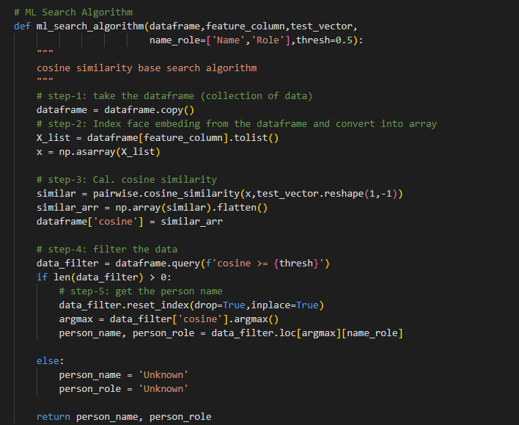
Figure 5.13 Cosine Similarity Algorithm
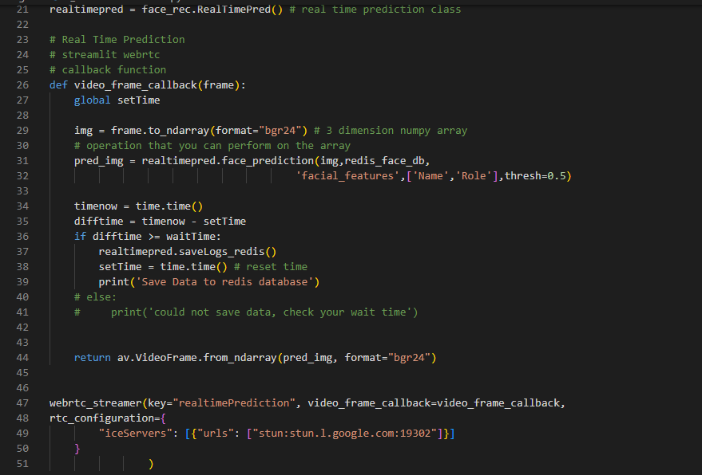
Figure 5.14 Real-Time Prediction Code Snippet
Figure 5.13 shows the algorithm used by the researcher for fast recognition of images and making predictions. The function returns the name and role, or an unknown value. The function was called in Figure 5.14 to make a real-time prediction. Figure 5.14 below shows the results from the function.
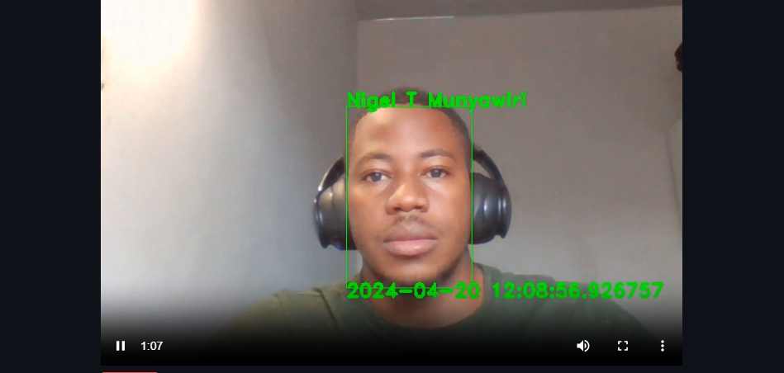
Figure 5.15 Real-time Prediction

Reporting
After working on the prediction function, the researcher worked on the function for saving the logs for reporting. The function saves the time, date of detection, and name of the person detected. Figure 5-16 shows the function of creating a data frame from logs.
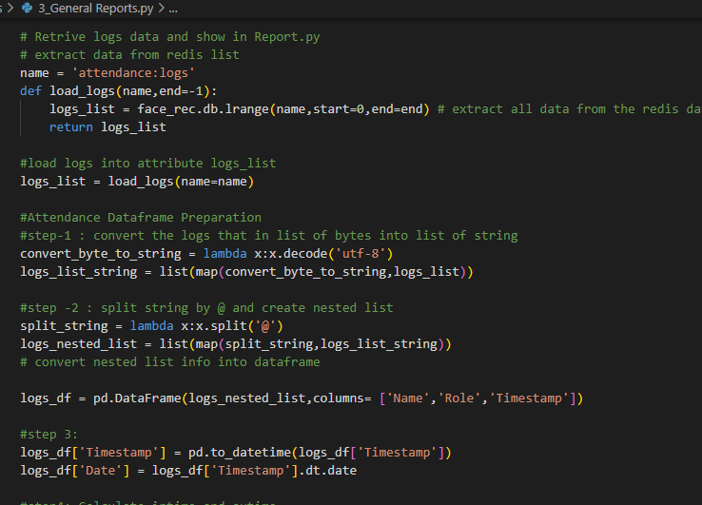
Figure 5.16 Reporting Code Snippet

System Authentication
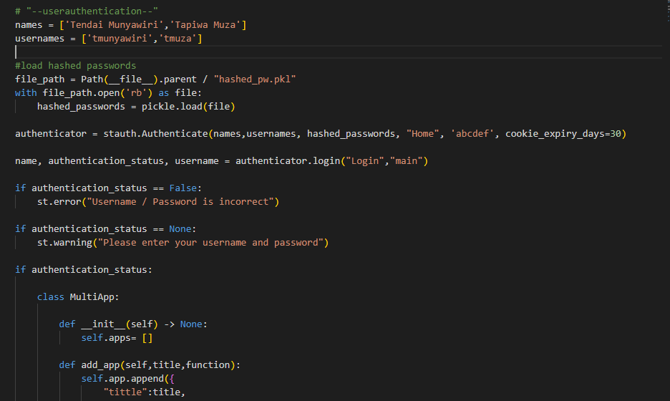
Figure 5.17 Admin System Authentication
Figure 5.17 shows the authentication on the system. The system uses the Streamlit authenticator service, which allows the user to add system users and store their passwords in a hashed file format. Streamlit authenticator provides a robust system security feature for authentication.

User Interface
The next product to be developed was the frontend user interface. The user interface acts as the main communication point of the system, allowing users to view attendance reports. The researcher created a flexible and simple web-based user interface. Sections that follow go over the system views that were created to permit various operations based on varying access rights.

Home Page
The home page is the initial stage that a user views when he opens the system. This page is accessed by everyone. It allows guardians and teachers to view general reports. Figure 5.18 below shows the home page interface.
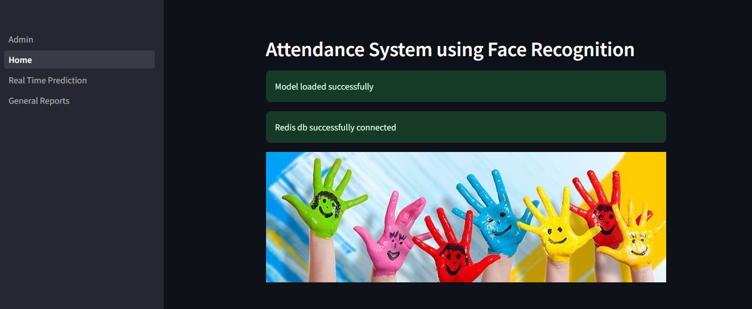
Figure 5.18 Home Page
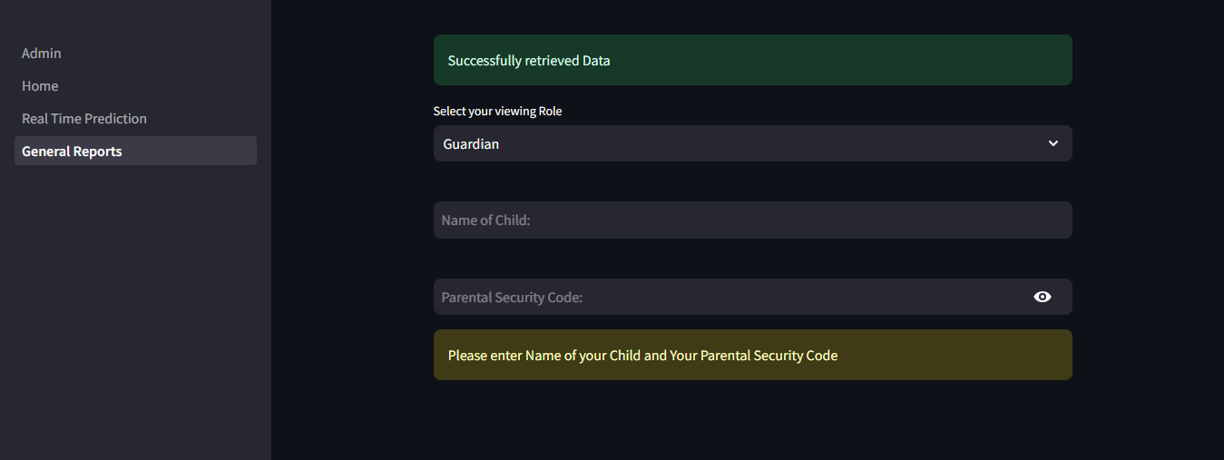
Figure 5.19 General Reports for Guardian
Figure 5.19 shows the general report view. The general user must select their role for viewing certain reports. If the user selects a guardian, they must enter the name of their child and their parental security code. If the security code is validated, then the attendance report for that particular child will be displayed. If the user selects their role as teacher, they must be able to see a view for teachers. Figure 5.20 below shows the general reports view for teachers, whereby they must first enter an authentication code to view attendance reports for students.
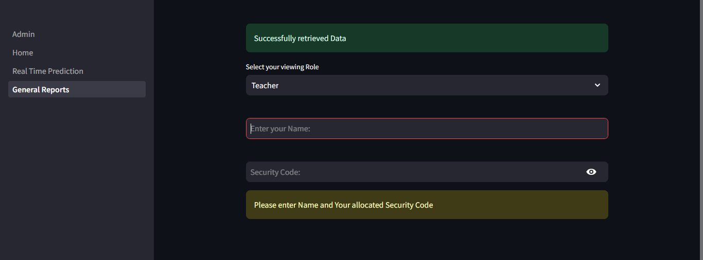
Figure 5.20 General Report View for Teachers

Real-time Prediction
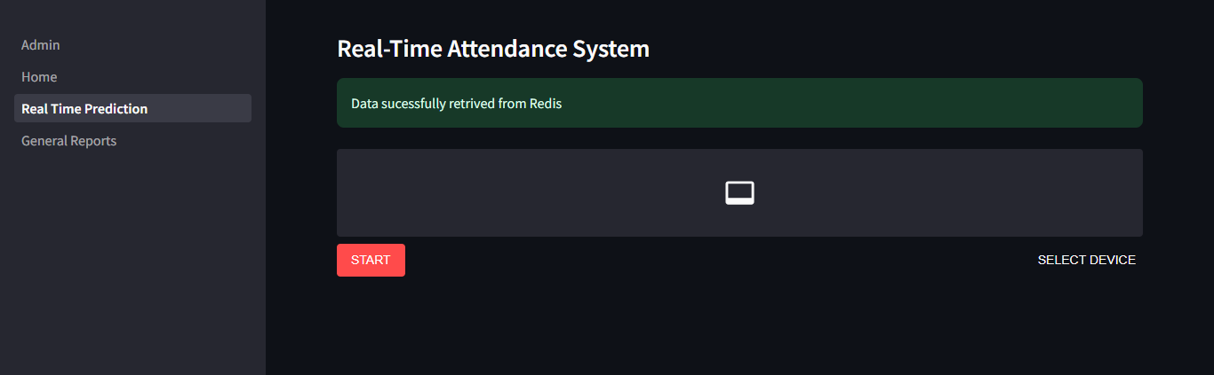
Figure 5.21 Real-Time Attendance Interface
Figure 5.21 shows the interface for taking real-time attendance. An administrator or teacher can press start to take real-time attendance. There is also an option to select the camera device, which can be a webcam or an external camera device.

Admin View and Dashboard
Figure 5.22 below shows the admin login interface, whereby the user enters the username and password. If the password is correctly validated, Figure 5.23 shows the Nursery Data Dashboard.
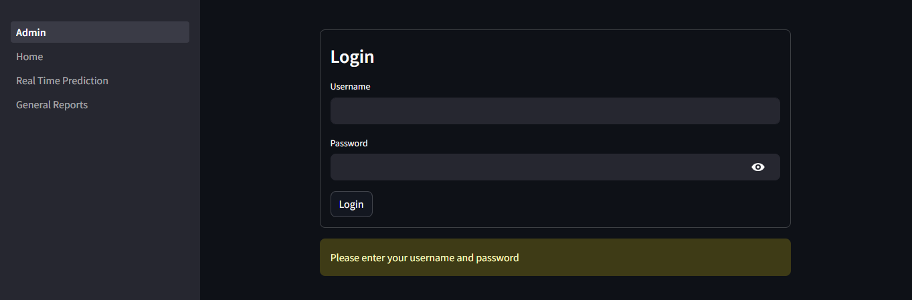
Figure 5.22 Admin Login Page
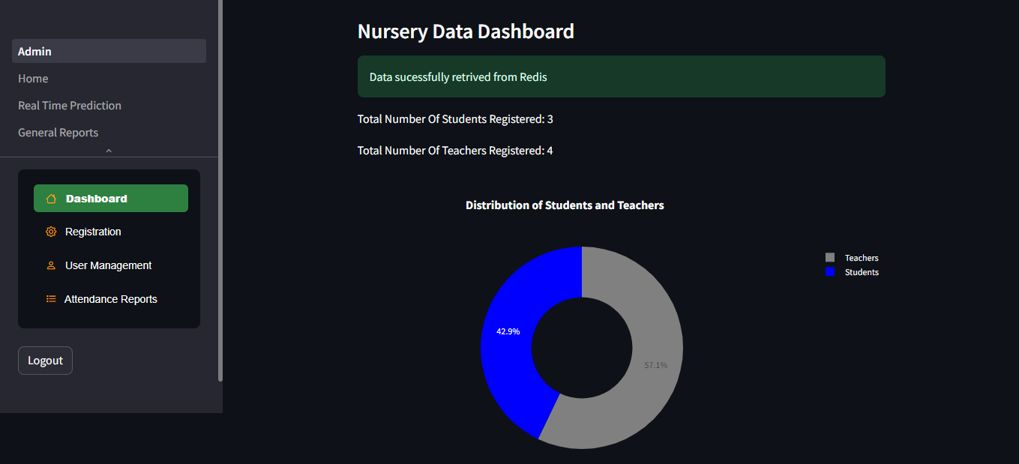
Figure 5.23 Admin View Interface and Dashboard

Registration Page
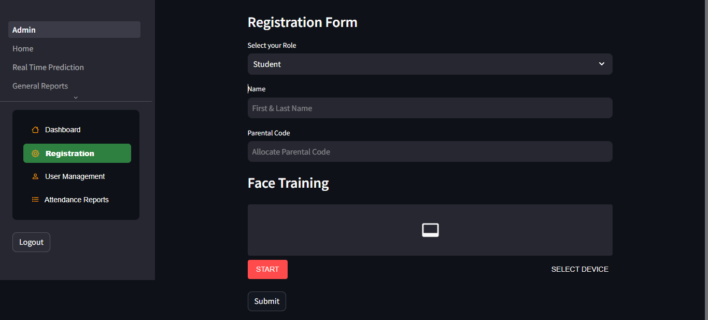
Figure 5.24 Registration Interface
Figure 5.24 shows the registration interface, where you select the role of the person you are registering and enter their details. The interface offers a view for training an individual's face into the model and stores information about the facial traits that have been extracted.

Attendance Reports
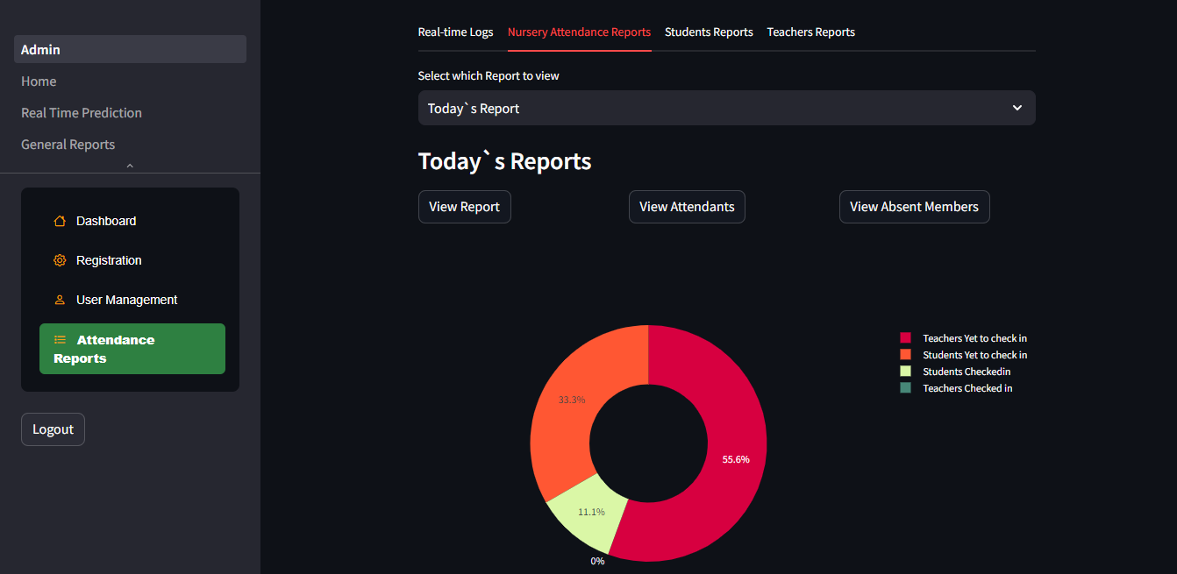
Figure 5.25 Nursery Attendance Reports Interface
Figure 5.25 shows the interface for nursery attendance reports. Administrators can select to view reports for that particular day or period-over-period reports. If the user selects to view for the current day, they can see a report for present and absent members. Figure 5.26 below shows the interface for period-over-period reports.

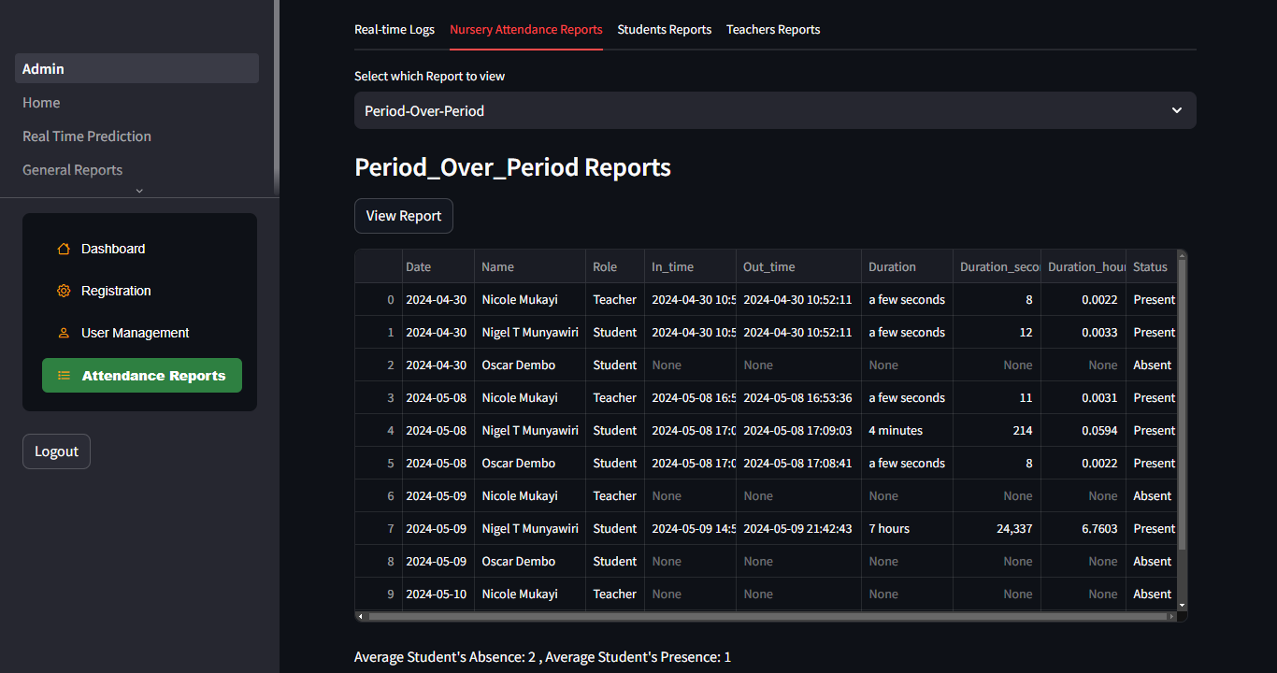
Figure 5.26 Period over Period Nursery Attendance Report
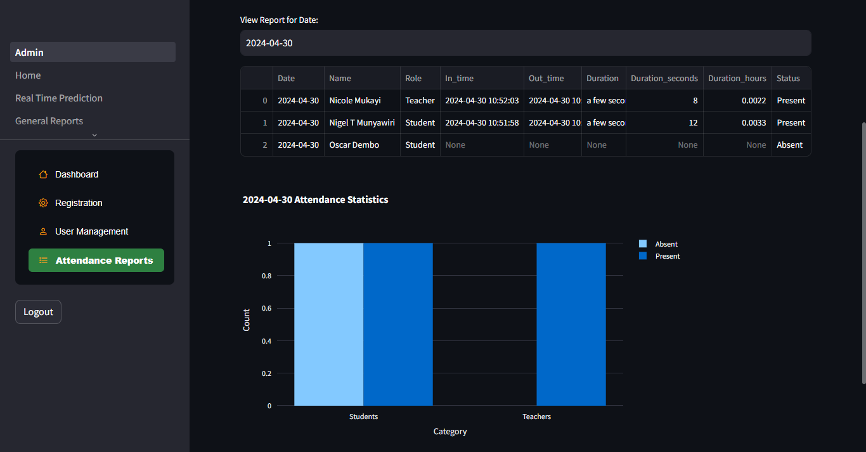
Figure 5.27 Reports for a certain Date
Figure 5.27 shows the interface for showing reports for a particular date and the attendance statistics. The statistics show the number of students and teachers absent and present on that particular day.
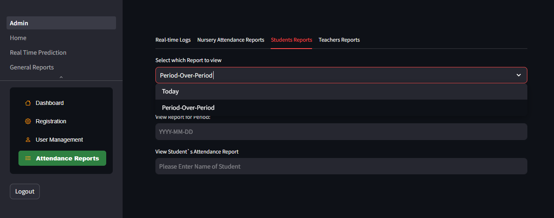
Figure 5.28 Students Reports Interface
Figure 5.28 displays the interface for students' reports with an option to select to view reports for the current day or a certain period. Figure 5.29 below shows the interface for current-day reports with an option to view present students or absent students.
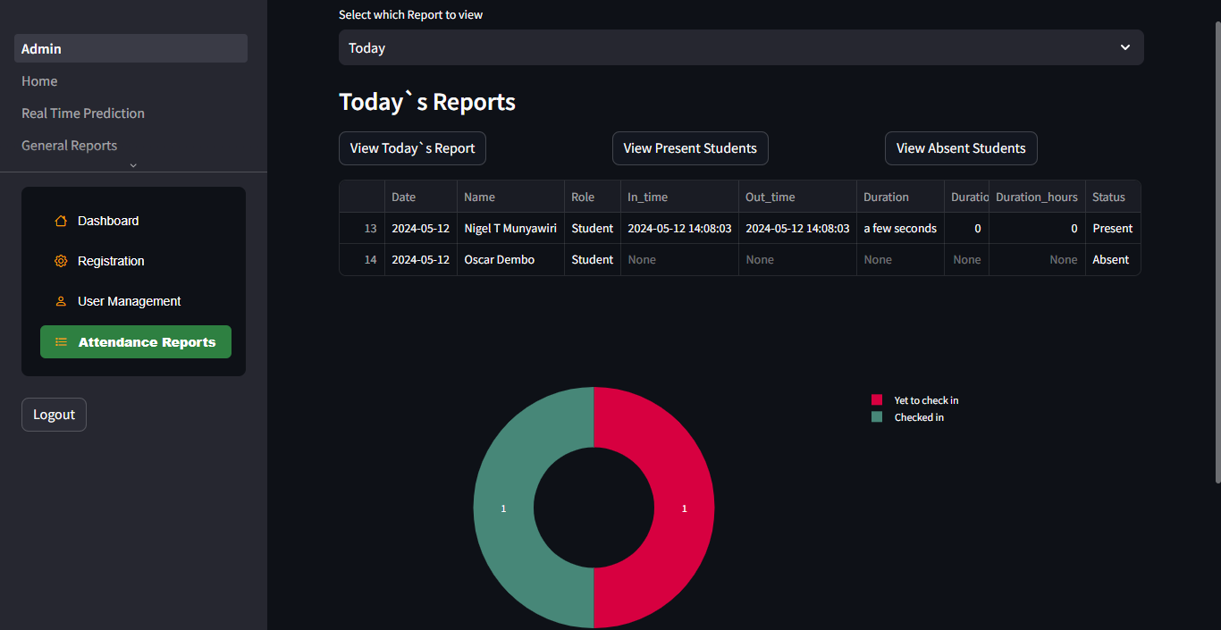
Figure 5.29 Current Day Reports for Students

Figure 5.30 Daily attendance statistics
Figure 5.30 shows the attendance daily statistics for each student and shows the student with the highest number of absent or present days. This information is vital for analysing the students’ performance about their attendance.
Figure 5.31 below shows the attendance report of a particular student, showing the attendance status for different dates.

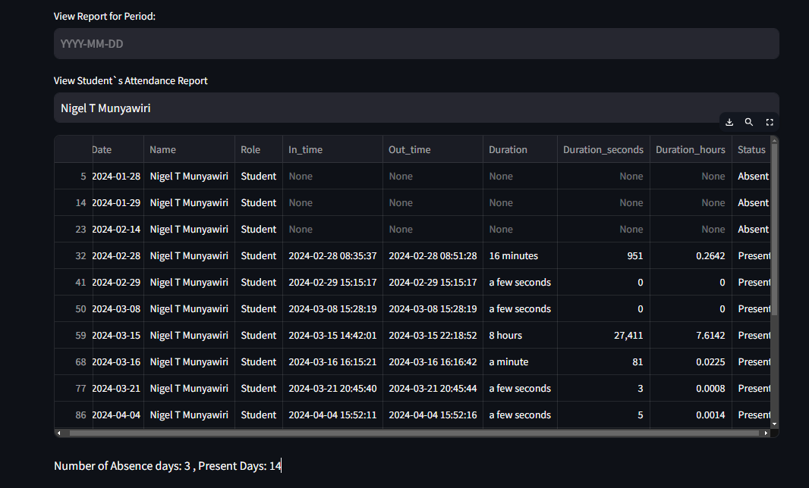
Figure 5.31 Particular Student`s Attendance Report
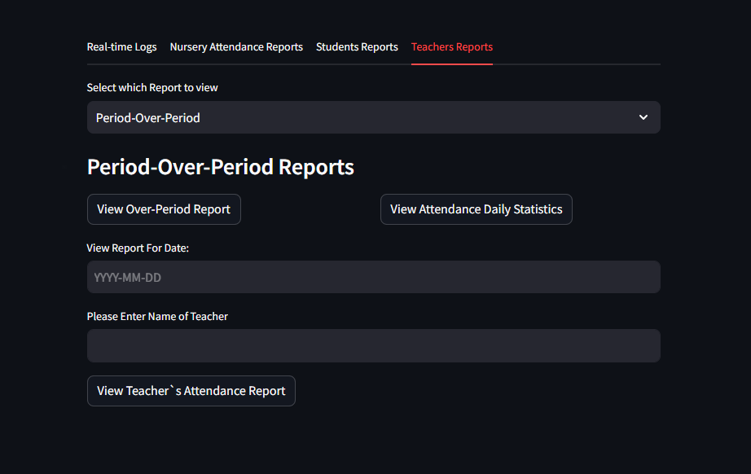
Figure 5.32 Teachers Attendance Reports
Figure 5.32 shows the interface for teachers' attendance reports. The teachers' attendance report interface has a similar interface to the students' report interface.

User Management
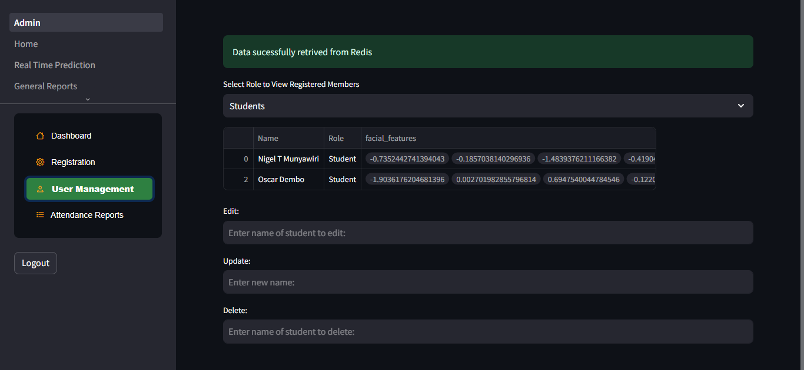
Figure 5.33 User Management Interface
Figure 5.33 shows the interface for user management. The interface displays a selection option that allows you to choose whether you want to view the list of registered students or teachers.

Database
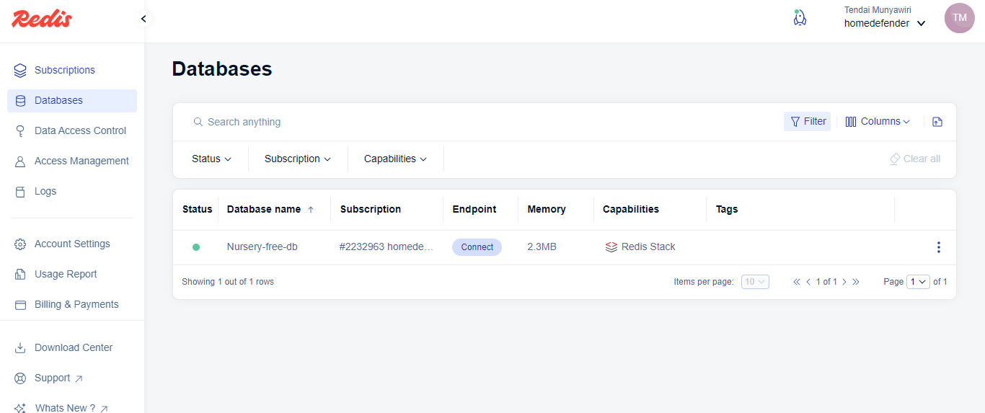
Figure 5.34 Redis Database Interface
Figure 5.34 shows the Redis database interface, where the administrator has access to the cloud database management and data access controls.

System Testing
After integrating various system components, the next step was to verify and validate that the overall system met the objectives and requirements of the research. The researcher conducted different tests to analyse and determine the operational efficiency of the system.

Unit Testing
Unit testing was conducted to test each system component and evaluate if the developed components were working correctly. The researcher also conducted tests on the interface to evaluate bugs within the system. Furthermore, tests were carried out to ensure that administrator access rights were not accessible to general users. These included features such as model maintenance and user registration. Database connections to various services were also tested to identify potential bugs.

Integration Testing
After completing unit tests, the researcher conducted integration testing to verify how the components performed when integrated into a single entity. The main components integrated were the user interface, backend application services, Redis database, and FastAPI that embedded the Insightface model. The essential goal of carrying out integration tests was to ensure that the overall system performed to acceptable standards about the specified objectives and requirements. The researcher carried out the tests continuously through every iteration in the development phases to resolve inconsistencies.

User Acceptance Testing
User acceptance testing involved presenting the system to end users to test the software and evaluate whether it could perform efficiently in a production environment. This was done by presenting the system to the research supervisors and getting feedback. Overall, the system got positive reviews, with valuable perceptions being gained towards improving the system.

Conclusion
The chapter focused on the implementation and testing of the facial recognition-based smart attendance system. System components were developed individually and finally integrated to form the overall system. System validations and testing were conducted to ensure usability, data integrity, and performance efficiency. Ultimately, the tests were conducted to ensure that the system met its defined objectives and requirements.

Conclusion

Introduction
This chapter gives a detailed conclusion to the project and evaluates the goals and objectives of the project. It also presents the challenges and limitations encountered during the development of the system and outlines future work and recommendations to improve it.

Review of Project Objectives
The following objectives for the research were stated in Chapter1:
- To detect the face segment from the video frame.
- To extract useful features from the detected face.
- To classify the features in order to recognize the face detected.
- To record the attendance of the identified student.

The Haar cascade algorithm was used to detect objects in images regardless of their scale and location. The Haar cascade algorithm is part of the Insightface model and can extract useful facial features such as face geometry and facial key points. The insightface model was also used to extract facial bounding box data, which was then used by the researcher to draw a bounding box using the OpenCV library. The researcher configured and integrated the model with the web application that provided an interactive user interface.

For the inference part, the insightface model was used as well to extract facial feature data. The researcher used the cosine similarity algorithm to classify the features detected and compare them with the saved features from the Redis database to recognise the faces detected. Therefore, this process enabled us to meet the third objective. The fourth objective was successfully met by creating a dictionary that can be used to append the name, the role, and the time of detection. The dictionary was then converted to a data frame, which provides the report in a structured format.

Challenges and Limitations
The major drawback of the developed system was network connectivity. The authentication service and the database were deployed in a cloud environment, thus making the system unusable in areas without network connectivity. Excess illumination and mask coverage posed another challenge in terms of extracting the exact facial features that would match with the registered samples and making the system read unknown but eventually recognise the actual face, thus making the system a bit accurate in terms of the time of detection. Another challenge faced was integrating the consent API. Implementing the API added complexity to the system architecture, and mapping user data to the API was challenging due to differences in data structures. However, the researcher addressed this by using a consent form to comply with the Cyber and Data Protection Act of Zimbabwe.

Future Work and Recommendations
Although the face recognition system has achieved numerous successes, there are still many areas that require further development and improvement. Here are some recommendations for future work:
- Ensuring that facial recognition systems are robust in real-world conditions: Currently, the system does not work effectively under real-world conditions such as low light or excess light.
- Consideration of ethical implications of Facial recognition technology: It is crucial to consider the ethical implications of facial recognition technology and its potential impact on privacy and security.
- More effective algorithms that easily distinguish identical twins: Current algorithms struggle to distinguish between identical twins.
- Adaptability to new and emerging threats: Finally, it is important to continue systems that can adapt to new and emerging threats, such as Deepfake and other digital manipulation schemes.

Conclusion
This chapter gives a review of the project by stating the extent to which its aims and objectives were achieved. This chapter also discussed challenges faced during the development life cycle of the system, and future improvements and recommendations for the future version of the system were highlighted. Overall, the developed system was able to use a deep learning model to detect and recognise faces and provide visualisation dashboards that presented a transparent view of the attendance report. Hence, all these features led to the achievement of the project aim, which was to provide a system that streamlined the process of monitoring student attendance to come up with reports that can be used to improve decision-making.

References

Alhanaee, K. et al. (2021) ‘Face recognition smart attendance system using deep transfer learning’, in Procedia Computer Science. Elsevier B.V., pp. 4093–4102. Available at: https://doi.org/10.1016/j.procs.2021.09.184.

Anwarul, S. and Dahiya, S. (2020) ‘A comprehensive review on face recognition methods and factors affecting facial recognition accuracy’, in Lecture Notes in Electrical Engineering. Springer, pp. 495–514. Available at: https://doi.org/10.1007/978-3-030-29407-6_36.

Al-Muhaidhri, G. and Hussain, J. (2019), Smart Attendance System using Face Recognition, INTERNATIONAL JOURNAL OF ENGINEERING RESEARCH & TECHNOLOGY (IJERT) Volume 08, Issue 12 (December 2019),

Bussa, S. et al. (2020) Smart Attendance System using OPENCV based on Facial Recognition. Available at: www.ijert.org.

Eridani, D. et al. (2021) ‘Internet of things-based attendance system design and development in a smart classroom’, Indonesian Journal of Electrical Engineering and Computer Science, 23(3), pp. 1432–1439. Available at: https://doi.org/10.11591/ijeecs.v23.i3.pp1432-1439.

Gavkare, A. et al. (2022) ‘Face Recognition Smart Attendance System-A Survey’, International Research Journal of Engineering and Technology [Preprint]. Available at: www.irjet.net
.
Hajo Wiemer, Lucas Drowatzky and Steffen Ihlenfeldt (2019) ‘Data Mining Methodology for Engineering Applications (DMME)—A Holistic Extension to the CRISP-DM Model’.

Hande, K.D. et al. (2023) SMART ATTENDANCE SYSTEM BASED ON FACIAL RECOGNITION USING RASPBERRY PI, Dogo Rangsang Research Journal UGC Care Group I Journal.

Jilcha Sileyew, K. (2020) ‘Research Design and Methodology’, in Cyberspace. IntechOpen. Available at: https://doi.org/10.5772/intechopen.85731.

Kadu, J. et al. (2023) ‘NO CONTACT SMART ATTENDANCE SYSTEM’, www.irjmets.com @International Research Journal of Modernization in Engineering, 6693. Available at: https://doi.org/10.56726/IRJMETS40148.

Kortli, Y. et al. (2020) ‘Face recognition systems: A survey’, Sensors (Switzerland). MDPI AG. Available at: https://doi.org/10.3390/s20020342.

Li, L. et al. (2020) ‘A Review of Face Recognition Technology’, IEEE Access, 8, pp. 139110–139120. Available at: https://doi.org/10.1109/ACCESS.2020.3011028.

Mammen Vinod, V. and S, S.C. (2020) ‘A COMPREHENSIVE STUDY ON ACADEMIC AND INDUSTRY AUTHENTICATION AND ATTENDANCE SYSTEMS’. Available at: www.ijstr.org.

Moolla, Y. et al. (2021) ‘Biometric Recognition of Infants using Fingerprint, Iris, and Ear Biometrics’, IEEE Access, 9, pp. 38269–38286. Available at: https://doi.org/10.1109/ACCESS.2021.3062282.

Nick Hotz (2023) Data Science Process Alliance. Available at: https://www.datascience-pm.com/crisp-dm-2/ (Accessed: 25 November 2023).

Puckdeevongs, A. et al. (2020) ‘Classroom attendance systems based on bluetooth low energy indoor positioning technology for smart campus’, Information (Switzerland), 11(6). Available at: https://doi.org/10.3390/INFO11060329.

Qureshi, R. (2020) ‘The Proposed Implementation of RFID based Attendance System’, International Journal of Software Engineering & Applications, 11(3), pp. 59–69. Available at: https://doi.org/10.5121/ijsea.2020.11304.

Raghu, A. et al. (2023) Student Attendance Monitoring System using IoT and RFID, International Journal of Scientific Research & Engineering Trends.

Rossi, R., Lazarini, M.A. and Hirama, K. (2022) ‘Systematic Literature Review on the Accuracy of Face Recognition Algorithms’, EAI Endorsed Transactions on Internet of Things, 8(30), p. e5. Available at: https://doi.org/10.4108/eetiot.v8i30.2346.

Shepley, A.J. (2019) DEEP LEARNING FOR FACE RECOGNITION: A CRITICAL ANALYSIS.

Swamilingappa Harakannanavar, S. et al. (2019) An Extensive Study of Issues, Challenges and Achievements in Iris Recognition, Asian Journal of Electrical Sciences. Available at: www.trp.org.in.

William, I. et al. (2019) XXX-X-XXXX-XXXX-X/XX/$XX.00 ©20XX IEEE Face Recognition using FaceNet (Survey, Performance Test, and Comparison).

Yang, H. and Han, X. (2020) ‘Face recognition attendance system based on real-time video processing’, IEEE Access, 8, pp. 159143–159150. Available at: https://doi.org/10.1109/ACCESS.2020.3007205.

Appendices

Appendix A: Parent Consent Form
Real-time Nursery Smart Attendance System Using Facial Recognition

Biometric Data Privacy Parent/ Employee Consent Form

